CHAPTER 1
INTRODUCTION

Building construction is a core branch of engineering dedicated to creating safe, functional, and durable structures. While having a secure shelter remains a fundamental human need, the modern reality of constructing a house presents major financial and technical barriers. Today, escalating material costs and high labor charges make independent homebuilding incredibly expensive. As a result, constructing a safe home is often entirely out of reach for the common man, whereas wealthier individuals can easily afford large, luxurious houses.
To address this critical economic gap, the Government of Telangana introduced the 'Indiramma Indlu' housing scheme. This initiative is specifically designed to provide safe and affordable housing for the poor. It delivers vital financial assistance directly to families who already own a plot of land but lack the funds required to actually construct a house.
Based on this government initiative, the focus of this project is the "Planning, Analysis and designing of Indiramma indlu by manual process". The primary objective is to engineer a highly efficient, single-story (G+0) residential building that maximizes space while strictly adhering to the scheme's economic constraints.
What defines this project is its engineering methodology: the entire structural design is executed completely manually. Instead of relying on automated structural software, every phase—from architectural planning and load calculations to structural analysis and the final design of concrete elements—is calculated strictly by hand. This rigorous manual approach demonstrates a deep understanding of structural behavior and ensures that the final building is safe, durable, and fully compliant with Indian Standard codes.
  - THE INDIRAMMA INDLU SCHEME
The "Indiramma Indlu" (Indiramma Housing) Scheme is a flagship social welfare initiative launched by the Government of Telangana on March 11, 2024, under the leadership of Chief Minister A. Revanth Reddy. The scheme was conceptualized to address the critical housing deficit among the Economically Weaker Sections (EWS), Below Poverty Line (BPL) families, and marginalized communities across the state.
Housing is not merely a structural provision; it is a fundamental driver of socio-economic stability. For decades, low-cost housing schemes have struggled with inadequate technical execution, poor material quality, and bureaucratic bottlenecks. The Indiramma Indlu scheme aims to rectify these historical failures by combining direct financial assistance with strict technical oversight.
For a Civil Engineering project focusing on Mahabubnagar and the wider Telangana region, this scheme presents a perfect case study in balancing cost constraints with structural integrity. The Phase 1 target encompasses the construction of 4.5 lakh houses across 119 constituencies with a staggering budget allocation of ₹22,000 crores.

The scheme strategically shifts the power of construction back to the beneficiary, heavily guided by state engineering wings to ensure safety and quality in every G+0 structure built.
1.1.1 Primary Objectives
- Eradication of Homelessness: Providing permanent, secure, and dignified housing for landless and homeless citizens in Telangana.
- Financial Empowerment: Offering direct financial aid of ₹5 lakh per household to eliminate the reliance on exploitative private loans.
- Social Inclusion: Earmarking specific quotas for Scheduled Castes (SC), Scheduled Tribes (ST), Backward Classes (BC), minorities, and transgender persons. Notably, 10,000 houses are reserved specifically for Chenchu tribal families via the Integrated Tribal Development Agency (ITDA).
- Honoring Activists: Allocating 250 sq. meter plots of land to individuals who actively participated in the Telangana Statehood Movement.
  - STATUTORY FRAMEWORK AND GOVERNMENT ORDERS (G.O.)
Understanding the bureaucratic and legal foundation is crucial for the execution strategy. The scheme operates strictly under a series of Government Orders that dictate everything from fund disbursement to committee formations.
1.2.1 G.O. MS No. 7 – The Master Guideline
Issued on March 9, 2024, by the Transport, Roads & Buildings (Housing) Department, G.O. MS No. 7 serves as the foundational text for the scheme.
- Commencement: Officially sanctions the commencement of the Indiramma Indlu scheme for houseless families.
- Technical Mandates: It specifies that all houses must have an RCC (Reinforced Cement Concrete) roof. The minimum built-up area is mandated at 400 square feet, which must include a kitchen and an attached or detached sanitary toilet.
- Execution Modality: It outlines that the construction will be beneficiary-led. However, technical guidance and phase-wise monitoring will be provided by government-appointed engineering personnel to ensure strict adherence to safety standards.
1.2.2 G.O. Ms. No. 33 – Grassroots Committees
Issued on October 11, 2024, this order mandates the formation of Indiramma Committees at the Gram Panchayat and Municipal Ward levels.
- Purpose: To decentralize the monitoring process and ensure transparency in beneficiary selection.

- Role in Execution: For a civil engineer managing these projects, these committees serve as the primary point of contact for resolving local site disputes, material transport logistics, and community coordination.
1.2.3 G.O. Rt No. 50 & Mobile App Integration
Issued early on January 31, 2024, this mandate focuses on Aadhaar Authentication under Section 7 of the Aadhaar Act, 2016. Subsequent circulars (like the one on December 12, 2024) introduced a mobile application developed by the Centre for Good Governance (CGG) for real-time field verification of the 80.54 lakh Praja Palana applications.
Beneficiary Typology and Assistance Model
The G.O.s divide the beneficiaries into two distinct execution tracks:
- Beneficiaries with Land: Families owning a small plot receive ₹5 lakh in financial assistance (₹6 lakh for SC/ST categories) disbursed in staged installments tied to construction milestones.
- Landless Beneficiaries: The government takes on the responsibility of allocating a land parcel measuring 70-80 square yards (or 250 sq. meters for Telangana movement activists) alongside the ₹5 lakh construction grant.
  - TECHNICAL SPECIFICATIONS AND PLANNING FOR G+0 HOUSING
For a Civil Engineering execution strategy, the focus must shift from political guidelines to concrete, steel, and structural mechanics. The mandate for a 590 sq. ft. G+0 house requires meticulous manual planning to ensure the ₹5 lakh budget is not exceeded while maintaining a safe, durable structure.
1.3.1 Avoidance of Over-Engineering
In low-cost rural and semi-urban housing, over-reliance on complex software analysis can lead to unnecessary, cost-inflating designs. For a standard 590 sq. ft. single-story (G+0) structure, manual drafting and calculating loads based on fundamental Strength of Materials and Theory of Structures is far more efficient and practical than using heavy analytical software. A clear, well-drafted 2D plan detailing load paths and room dimensions is the core of the execution strategy.
1.3.2 Spatial Planning & Layout
- Dimensions: Minimum 400 sq. ft.
- Components: One multi-purpose living area, one bedroom, a dedicated kitchen space, and a toilet/bath area (often planned slightly separate from the main living area in rural contexts for hygiene and ventilation).
- Ventilation: Standardized window placements to ensure cross-ventilation, reducing the need for artificial cooling.

1.3.3 Structural Design Parameters
- Foundation: Given the typical hard soil conditions in the Deccan Plateau region, a standard strip footing or isolated column footings of minimal depth (typically 1.2m to 1.5m) are sufficient.
- Superstructure (Brick/Block Masonry): To optimize costs, load-bearing masonry walls (using high-quality fly ash bricks or standardized red clay bricks) are preferred over a fully framed RCC structure for G+0. Walls are typically 9 inches for the exterior and 4.5 inches for interior partitions.
- RCC Detailing: The G.O. strictly mandates an RCC roof. This is where your expertise in RCC design is critical. The slab thickness should be optimized (typically 100mm to 125mm for small spans) using standard M20 grade concrete.
- Steel Structures: While the primary structure is RCC and masonry, minor steel elements (Fe500 grade) for lintels, sunshades, and door frames must be calculated precisely to avoid material wastage. Reinforcement detailing in the slab must balance safety against wind/live loads with strict budget constraints.
  - EXECUTION STRATEGY AND PROJECT MANAGEMENT
To successfully execute an Indiramma Indlu project, a Civil Engineer must act as both a technical guide and a project manager. The ₹5 lakh budget is tight; therefore, the execution strategy must revolve around zero material wastage and localized supply chains.
1.4.1 Material Procurement
- Local Sourcing: In districts like Mahabubnagar, sourcing coarse aggregate, fine aggregate (sand), and bricks locally drastically reduces transportation overheads.
- Standardization: Using standardized doors and windows across multiple units allows for bulk manufacturing discounts.
1.4.2 Phase-Wise Construction and The L-Stage Checks
The financial assistance is not handed over as a lump sum. It is strictly tied to physical progress, monitored by government engineering wings. Your project plan must align perfectly with these stages:
- L1 Stage (Basement/Plinth Level): * Action: Excavation, foundation laying, and raising the structure to the plinth level.
  - Quality Check: The inspecting officer checks the alignment, trench depth, and the quality of baseline materials (sand cleanliness, brick strength).
  - Fund Release: The first installment is released upon L1 approval.

- L2 Stage (Lintel/Roof Level): * Action: Raising the masonry walls to the lintel level and preparing the formwork and reinforcement for the RCC slab.
  - Quality Check: Verification of room sizes against the approved drafted plan, wall thickness, and visual inspection of steel reinforcement before the concrete pour.
  - Fund Release: Second installment.
- L3 Stage (Completion): * Action: Pouring the RCC slab, curing, plastering, flooring, and finalizing basic electrical and plumbing (water and toilet) connections.
  - Quality Check: Final structural inspection, ensuring the RCC roof is solid, the toilet is functional, and the minimum 400 sq. ft. mandate is met.
  - Fund Release: Final installment.
  - CHALLENGES AND RISK MITIGATION IN IMPLEMENTATION
No engineering project is without hurdles, and public housing is notorious for ground-level friction. A comprehensive documentation must address these risks.
1.5.1 Bureaucratic and Financial Delays
- The Risk: Government funds often face delays due to budget approvals or administrative bottlenecks. Slow fund releases stall construction, leaving partially built structures exposed to weather.
- Mitigation Strategy: Beneficiaries must be counseled on staging their material purchases. Engineers should plan construction schedules that avoid leaving critical elements (like open trenches or un-poured slabs) exposed during the monsoon season.
1.5.2 Material Quality Control
- The Risk: To save money, beneficiaries might procure sub-standard cement or under-gauged steel, jeopardizing the RCC roof's integrity.
- Mitigation Strategy: Visual checks and basic on-site material testing (like the slump test for concrete workability or field tests for brick strength) must be heavily emphasized in the execution strategy.
1.5.3 Documentation and Land Disputes
- The Risk: Missing BPL cards, unresolved land ownership on ancestral property, or un-regularized plots (which ties into LRS schemes) can halt the L1 approval entirely.
- Mitigation Strategy: Pre-construction clearance is vital. The technical team must ensure the land is free of legal encumbrances before any physical excavation begins.

1.6 CLASSIFICATION OF BUILDINGS:
According to National Building Code of India, 1983, all buildings whether existing or to be constructed are classified based on the character of occupancy in one of the following groups,
GROUP-A : Residential Buildings
GROUP-B : Educational Buildings
GROUP-C : Institutional Buildings
GROUP-D : Assembly Buildings
GROUP-E : Business Buildings
GROUP-F : Mercantile Buildings
GROUP-G : Industrial Buildings
GROUP-H : Storage Buildings
GROUP-I : Hazardous Buildings
In this project the government new house scheme “Indiramma indlu” is for Residential building, the definition and the examples of buildings in Group-A residential building are given below.
GROUP-A: Residential Buildings:
These include any building in which sleeping accommodation is provided for normal residential purposes with or without cooking or dining or both facilities.
Buildings and structures under group –A are further subdivided as below:
Subdivision A-1: Loading or rooming houses:

Figure 1.1: Lodging or Rooming House.
These include any building or group of buildings under the same management. These are provided with a separate sleeping accommodation for a total of not more than 15 persons either on temporary or permanent basis. These may be with or without dining facilities, but no facilities for cooking.
Subdivision A-2: One- or two-family private dwelling:

Figure 1.2: Single family private dwelling.
These include any private dwelling which is occupied by members of a single family having sleeping accommodation for not more than 20 persons.
Subdivision A-3: Dormitories:
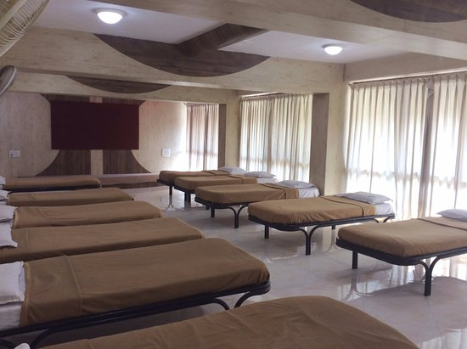
Figure 1.3: Dormitories.
These include any building in which group sleeping accommodation is provided with or without dining facilities .In the persons will not be the members of same family.
EX : School and college dormitories, student’s and other hostels and military barracks.
Subdivision A-4: Apartment houses (Flats) :
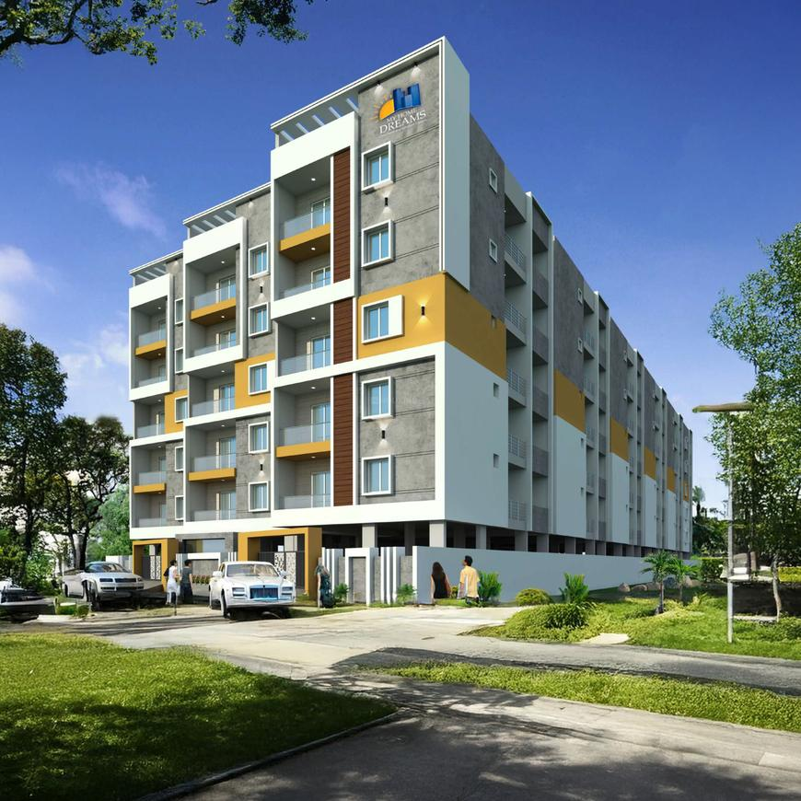
Figure 1.4: Apartment houses.
These include any building or structure in which living quarters are provided for three or more families. They live independently of each other with independent cooking facilities.
EX: Apartment houses, mansions.
Subdivision A-5: Hotels:

Figure 1.5: Hotels.
These include any building or group of buildings under the single management. In this sleeping accommodation with or without dining facilities is provided for hire to more than 15 persons who are purely temporary.
EX: Hotels, Inns, Clubs & motels.

1.7 METHODOLOGY:
Methodology of the project is as follows:

Figure 1.6: Flow chart.

1.8 PROJECT DETAILS:
In this project, we didn’t just want to use Random Dimensions for Plot, So the first thing we did was visit a real site of beneficiary who got Shortlisted in this Scheme. Instead of guessing standard dimensions, we surveyed an actual plot of land handed out under the Indiramma Indlu scheme. Getting our boots on the ground meant we could design a house that is actually ready to be built in the real world. We got a plinth area of 54.82m² (590sq. ft).
The Government order says beneficiaries to strictly follow the approved plan of two rooms, kitchen and toilet, with plinth area between 400 to 600 sq. ft. Our plinth area is 590sq. ft. So our plot is under the guideline and Eligible for this Scheme.
During the site visit, we gathered these exact real-world details:
- The Beneficiary: The plot belongs to Smt. B. Kanakamma. Understanding her family's daily needs helped us create a room layout that is actually practical for them to live in.
- The Location: The site is located in Mannapur Village, Kothapalle Mandal, in the Narayanpet District.
- Plot Size & Facing: We measured the site boundaries and recorded a total plot size of 8.05m x 6.81m. The plot faces North, which is a huge detail—it told us exactly where to place the main entrance and how to arrange the windows to get the best natural light and airflow.
- House Dimensions: After leaving the required empty space around the edges of the plot, we locked in a final building area (plinth area) of 590 sq. ft. The actual floor plan of the house is designed at 5.9m x 6.68m.
Using this real site data and keeping the government's strict budget in mind, we set our final structural rules. The building is designed as a simple single-story (G+0) house with a 3.0m ceiling height. For all of our manual calculations, we are using M20 grade concrete and Fe-500 grade steel.
For the economical and safety purpose a proper design is needed, we have done the planning with reference to “National Building code 2016” for interior and exterior plans. these plans are molded in AutoCAD software for drawings. The structural analysis is done manually whereas the designing of various structural components (such as slab, beams, columns, footing etc.) is carried out using “Bureau of Indian Standard Code books” (Given in reference) according to ‘limit state method’. The site plan and plot size are shown in figure 1.7 & 1.8.

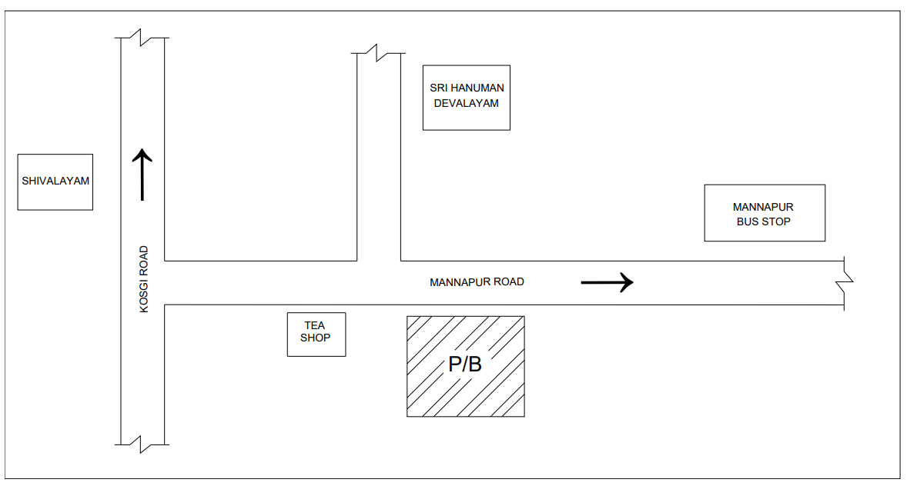
Figure 1.7: Location plan.

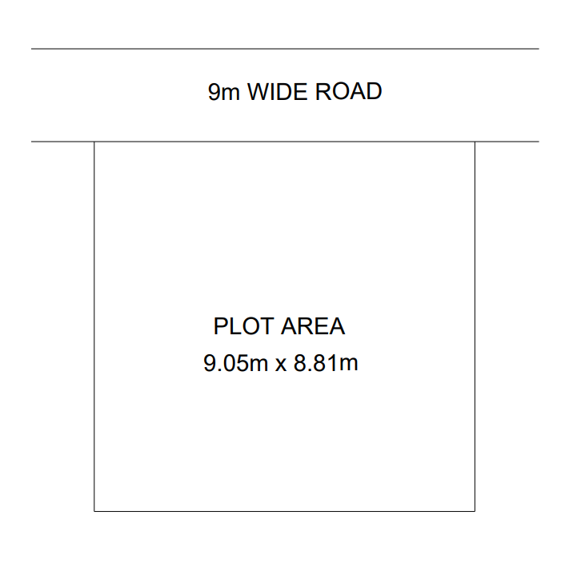
Figure 1.8: Plot size.

CHAPTER 2
PLANNING

The term "planning" in building construction refers to the strategic arrangement of all building units across all floors and levels. It encompasses not only the horizontal layout but also the vertical elevation, ensuring that the spaces enclosed by walls, floors, and roofs are optimized for their intended use.
During the planning phase, it is critical to keep the general purpose of the building at the forefront. Because each building type has unique requirements to fulfill its purpose effectively, deep consideration must be given to the functional and utility aspects of the design. For this specific Indiramma Indlu housing scheme project, the design focuses on maximizing space utility for multiple residential flats while adhering to statutory regulations.
The main considerations guiding this planning process include:
- Human habitation needs and spatial requirements.
- Climatic conditions and their effects on ventilation and lighting.
- Adherence to Building Bye-laws for legal planning and construction.
- Available finance and economic feasibility.
- Overall comfort, safety, and structural economy.
2.1 Road Widening Width: Proper Road access is essential for future urban development. The specification for the road widening width is adopted from G.O.Ms.No.168. According to these guidelines, a road widening width for future road development must be provided at a minimum of 4.5 m from the center line of the existing road.
Figure 2.1: Plot area.
2.2 Setbacks Setbacks ensure adequate natural light, ventilation, and fire safety access around the structure. The specifications for setbacks are also derived from Table 3 of G.O.Ms.No.168. For this plot, a 1.5m free space is provided at the front of the building, while 0.5m of free space is maintained on the sides and the rear as setbacks.
After deducting these setbacks from the gross plot area of 9.05m x 8.81m (79.73 m²), the resulting net plot area available for the main building footprint is 8.05m x 6.81m (54.82 m²). This net area serves as the boundary for the primary structural planning.

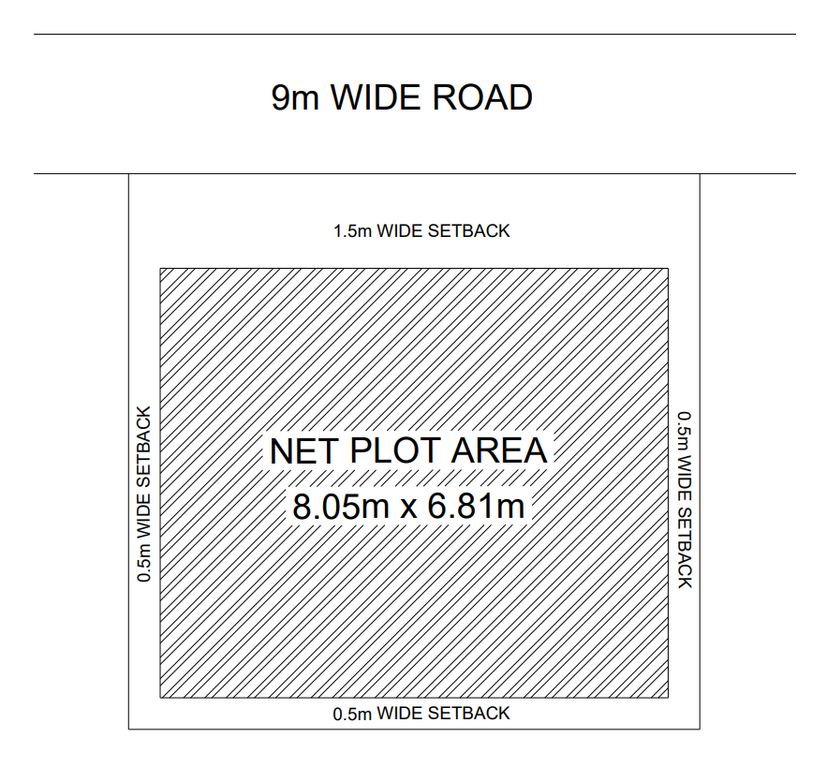
Figure 2.2: Net Plot Area.
2.3 REQUIREMENTS OF PARTS OF BUILDINGS
To ensure safety, livability, and compliance with the Telangana State Government guidelines for the Indiramma Indlu Scheme, the specifications for the building's components follow the mandatory scheme provisions combined with the "National Building Code (NBC) 2016 Part 3: Development Control Rules and General Building Requirements" for Low-Income Housing (EWS).
The scheme explicitly mandates a G+0 pucca structure, an RCC roof, and a minimum built-up area of 400 sq. ft. (approx. 37.16 m²). The requirements for various parts of the building are strictly in accordance with these parameters.

2.3.1 Plinth
- Main Building: The plinth of the single-story main building must be located relative to the surrounding ground level to guarantee adequate site drainage. The height of the plinth shall not be less than 450 mm from the surrounding ground level to prevent water logging and ensure a durable foundation.
- Plinth Area Constraints: As per the scheme's standard layout guidelines, the total constructed plinth area (built-up area) must meet the minimum requirement of 400 sq. ft. to qualify for the full government financial assistance.
2.3.2 Habitable Rooms
- Height: The vertical clearance of all human habitation rooms must not be less than 2.75 m, measured from the finished floor surface to the lowest point of the ceiling (bottom of the RCC slab). The clear headroom under any structural beam shall be at least 2.4 m.
- Size: To fit efficiently within the 400 sq. ft. layout, the primary habitable room shall have an area of not less than 9.5 m² with a minimum width of 2.4 m. For the secondary room (bedroom), the area must be at least 7.5 m², with a minimum width of 2.1 m.
2.3.3 Kitchen
- Height: Kitchen height must not be less than 2.75 m from the floor to the lowest ceiling point.
- Size: A separate kitchen is a mandatory inclusion under the Indiramma Indlu scheme. The kitchen must have a minimum floor area of 4.5 m² (or 3.3 m² as per minimum EWS standards to conserve space) with a minimum width of 1.5 m.
- Other Requirements: Every kitchen must have a proper sink connected to a grated waste pipe, an impermeable floor, and adequate ventilation openings as specified by NBC 20.1.1.
2.3.4 Bathrooms and Water-Closet
- Height: Minimum height is 2.1 m from floor to ceiling.
- Size: A sanitary toilet facility is mandatory. Independent bathrooms must be at least 1.8 m² (minimum width 1.2 m), and independent water-closets must be 1.1 m² (minimum width 0.9 m). Combined bath and water-closet units, as utilized in this plan to optimize the 400 sq. ft. footprint, must have a floor area of not less than 2.8 m² with a minimum width of 1.2 m.
- Other Requirements: At least one wall must open to the external air. Surfaces must be impervious up to 1 m high, and floors must slope toward the drain. A ventilation shaft or exhaust opening of at least 0.3 m² is required.

2.3.5 Parapet and Roof
- Roof Specification: An RCC (Reinforced Cement Concrete) roof is strictly mandatory for this scheme to ensure a permanent, weather-resistant structure.
- Parapet: Parapet walls on the RCC roof edges shall be maintained between 1.0 m and 1.2 m in height from the finished floor level for optimal safety.
2.3.6 Boundary Wall
Standard boundary walls around the allotted plot (typically 250 sq. yards for landless beneficiaries) should have a maximum height of 1.5 m above the front street's center line. Corner plots restrict solid boundary wall heights to 0.75 m for a length of 10 m at intersections to maintain clear sightlines for traffic.
2.3.7 Staircase
- Minimum clear width: As this is a G+0 single-family low-cost dwelling, an internal or external staircase may be provided strictly for access to the RCC roof (allowing for future vertical expansion by the beneficiary). Following NBC standards for Low-Income Housing (EWS), a minimum clear width of 0.9 m is sufficient.
- Treads & Risers: The minimum tread width is optimized to 250 mm for single-family dwellings. To conserve space within the plot footprint, the maximum riser height can be up to 190 mm.
- Headroom: A minimum clear headroom of 2.2 m must be maintained throughout the staircase flight and under any landings.
2.3.8 Exit Requirements Given the single-story (G+0) nature and the compact 400 sq. ft. footprint of the dwelling, complex corridor routing is not applicable. Exit requirements are straightforwardly met through direct access from the main living area to the exterior. All door placements and widths are designed to ensure immediate, unobstructed egress to the outside to ensure rapid evacuation capabilities.
2.4 Plinth & Carpet Area Applying the mandatory scheme specifications to the allotted plot area, the designed layout achieves a highly efficient footprint that maximizes the living space while remaining strictly within the budget and guidelines. We have established a total plinth area (built-up area) of exactly 400 sq. ft. (approx. 37.16 m²) to qualify for the full government financial assistance.
Subtracting the area occupied by the external and internal walls, the floor plan yields an optimized net carpet area.
The ground floor layout details the spatial arrangement of the mandatory components: the primary living area, the bedroom, the separate kitchen, and the combined bath/WC unit. This arrangement optimizes internal circulation, natural lighting, and cross-ventilation within the compact boundary.

CHAPTER 3
CALCULATION OF LOADS & ANALYSIS
3.1 Types of loads:
1. Dead load
2. Live load
3. Wind load
4.Earth quake load
3.1.1 Dead load (DL):
Dead load is a permanent and stationary vertical load which is subjected to the structure mainly due to the self-weight of the structural components such as beams, slabs, columns and walls etc. it also includes the weight of permanently fixed equipment. The dead load acts on the structure throughout its life time.
The dead load can be calculated by multiplying the volume of the structural component and the unit weight of the material. The unit weights of the different materials are given in the IS 875 part-1 : 1987.
3.1.2 Live load (LL):
Live load also called as imposed load, these are the loads which are moving or movable without any acceleration or impact. These loads are subjected to the structure occupancy of the building including weights of movable partitions or furniture etc.
Live loads keep on changing from time to time. The minimum values of live loads to be assumed are given in IS 875 (part 2)–1987. It depends upon the intended use of the building.
3.1.3 Wind load:
These types of loads are imposed by the wind. The structure should be strong enough with the heavy dead weights and anchored to the ground to resist this wind load. If not, the building foundation may fail. Wind load acts horizontally towards roofs, walls and columns.
The specifications for wind loads are given in IS 875 part 3 : 1987,
As per National Building Code Structure of 15 m height and above is to be considered for wind load.
3.1.4 Earth quake load:
Earthquake forces constitute to both vertical and horizontal forces on the building. The total vibration caused by earthquake may be resolved into three mutually perpendicular directions, usually taken as vertical and two horizontal directions. The movement in vertical direction do not cause forces in superstructure to any significant extent. But the horizontal movement of the building at the time of earthquake is to be considered while designing.
As our plot is not in the earthquake prone area, we have not considered the earth quake loads in this project.

3.2 Load calculation on slab:
The slab is divided into smaller slabs resting on beams, each slab acts as the continuous slab. The loads on the slabs are calculated as follows:
3.2.1 Dead load calculation:
The dead load can be calculated by multiplying the volume of the structural component and the unit weight of the material used. The unit weights of the materials used,[which are taken from the IS 875 part-1 : 1987] are given below.
S. No | Materials | Unit weight KN/m³
1 | Reinforced cement concrete | 25
2 | Plain cement concrete | 24
3 | Common burnt clay Bricks | 15.7-18.85
Table 3.1: unit weight of the materials used.
Slab load:
The slab thickness is assumed as 100 mm.
Self-weight of the slab = 1 x 1 x 0.10 x 25
= 2.50 KN/m²
Weight of weathering course = 1 KN/m²

Dead Load = 3.5 KN/m²
______________________________________

Parapet load:
Self-weight of the parapet wall = 1 x 1 x 0.1 x 18
= 1.8 KN/m

Beam load:
Self-weight of the beam = 1 x 0.23 x 0.3 x 25
= 1.725 KN/m

Wall load:
Self-weight of the 9” wall = 1 x 0.23 x 2.7 x 18= 11.18 KN/m
Self-weight of the 4” wall = 1 x 0.10 x 2.7 x 18= 4.86 KN/m

3.2.2 Live load calculation:
Live load on roof slab:
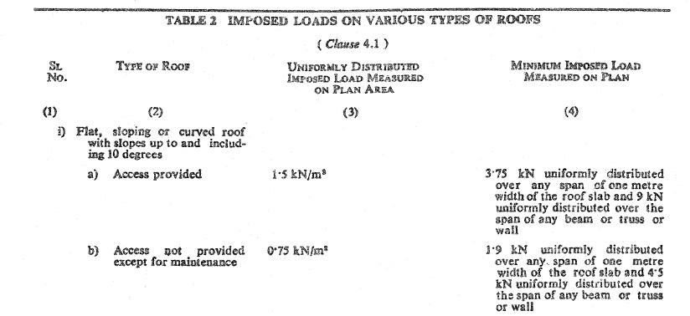
The live load on roof [which is given in IS 875 part 2 -1987, page No. 14, table No. 2] is shown in figure 3.1.
Figure 3.1: Imposed load on roof.
The imposed load on the roof slab is taken as 1.5 KN /m² because the access is provided to the roofs.
Live Load on floor slab:
Live load on floor slab based on occupancy is shown in figure 3.2. [which is given in IS 875 part 2 -1987, page No. 7, table No. 1].
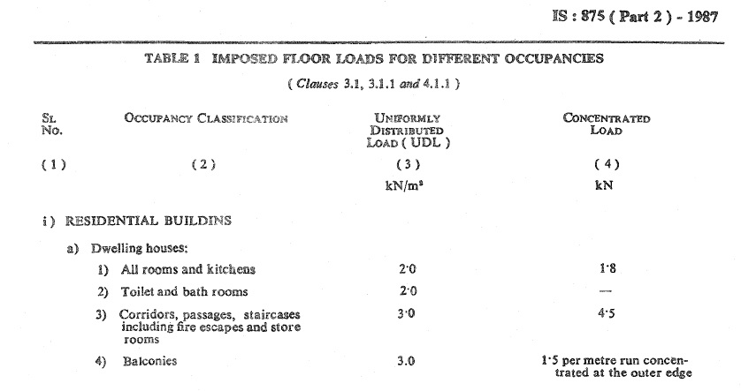
Figure 3.2: Imposed load on floor slabs.

The imposed load on the floor slab is taken as 2 KN /m² for all rooms & kitchen and for corridors & balconies the load is taken as 3KN/m².
3.3 Load distribution from slab to beams:
Load is distributed in beams based on type of slab (according to ly/lx ratio).
Type of slab based on ly/lx ratio:
One-way slab: if the ly/lx ratio of the slab is greater than or equal to 2 then the slab is considered as one-way slab.
two-way slab: if the ly/lx ratio of the slab is less than 2 then the slab is considered as two-way slab.
Where,
ly = longer span of the slab
lx = shorter span of the slab
In case of one-way slab, the loads are distributed evenly on both longer sides of slab in the form of rectangles which can be calculated by multiplying load and the area of rectangle.
In case of two-way slab, the loads are distributed to the beams in the form of triangles and trapezoids. The following formulas are used to calculate the distributed loads on beans.
For triangle - $\frac{wl_{x}}{3}$
For trapezoid - $\frac{wl_{x}}{2} (1-\frac{1}{3β^{2}})$
Where,
$β= \frac{l_{y}}{l_{x}}$

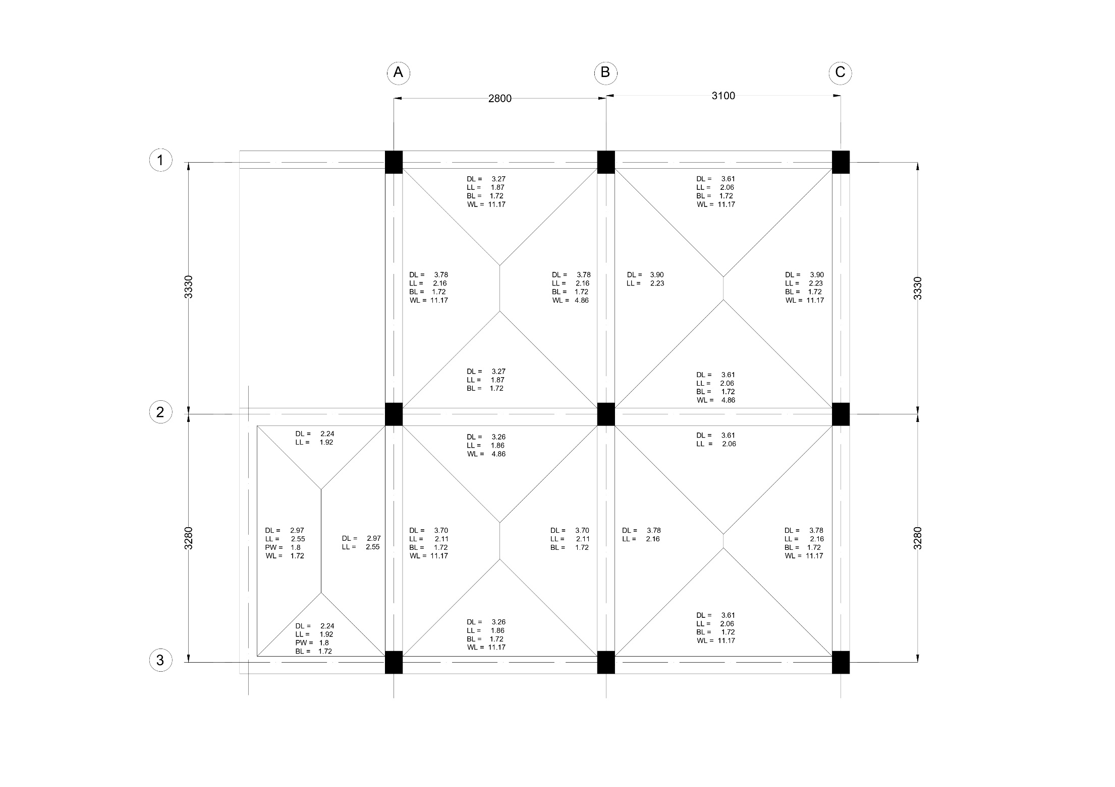

Figure 3.3: Roof slab loads.

3.4 Structural frames:
3.4.1 Loads on structural frames:
The loads coming from slabs and walls and the self-weight of the beam are taken as the uniformly distributed load (UDL) and the load which is transferred to the main beam(which are supported or directly connected to the columns) by the sub beams (which are supported by main beams or connected to the main beams) in the form of support reactions is taken as point load
The following figures shows the structural frames caring loads.
(Note: DL= Dead Load, BL = Beam Load, PW = Parapet Load, WL = Wall Load, LL= Live Load).
Frame A1-B1-C1:
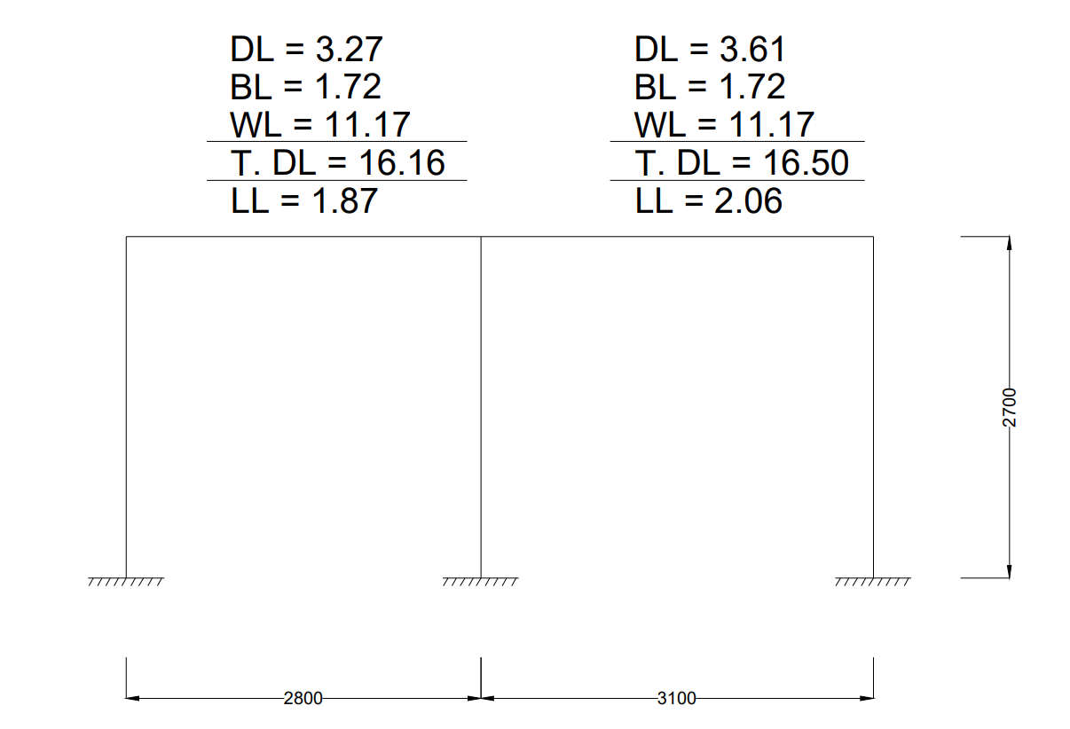
Figure 3.4: Load calculation in frame A1-B1-C1.

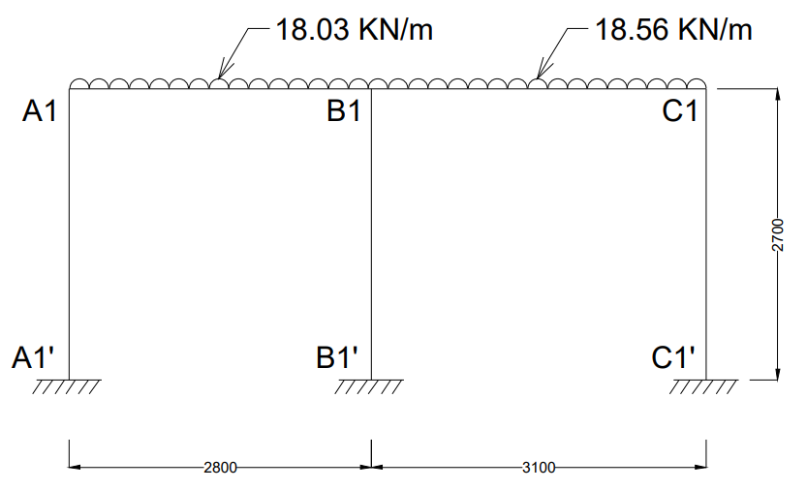
Figure 3.5: Frame A1-B1-C1 with loads.

Frame A2-B2-C2:
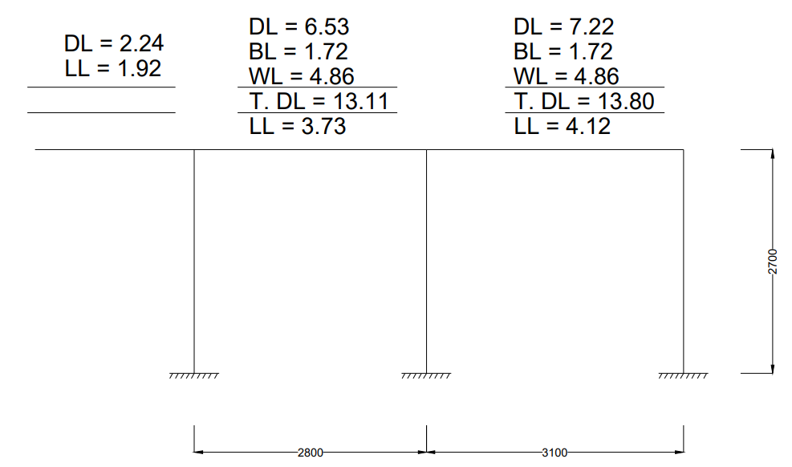
Figure 3.6: Load calculation in frame A2-B2-C2.

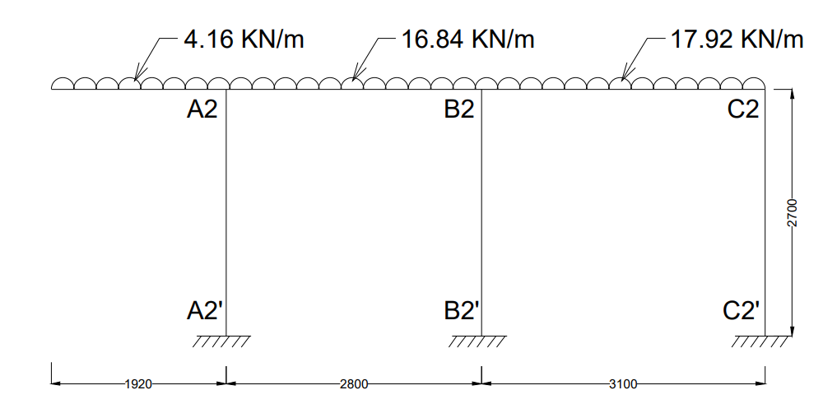
Figure 3.7: Frame A2-B2-C2 with loads.

Frame A3-B3-C3:
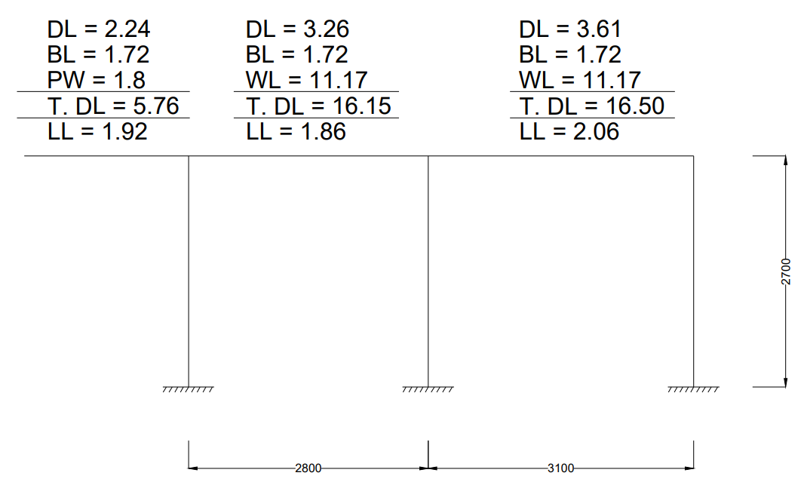
Figure 3.8: Load calculation in frame A3-B3-C3.

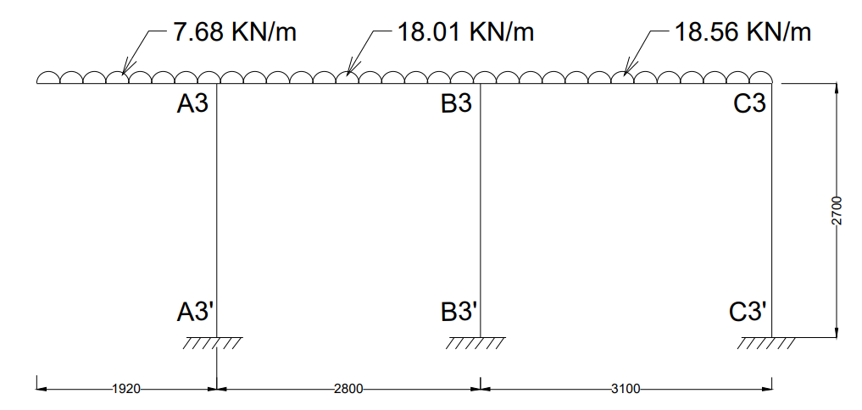
Figure 3.9: Frame A3-B3-C3 with loads.

Frame A1-A2-A3:
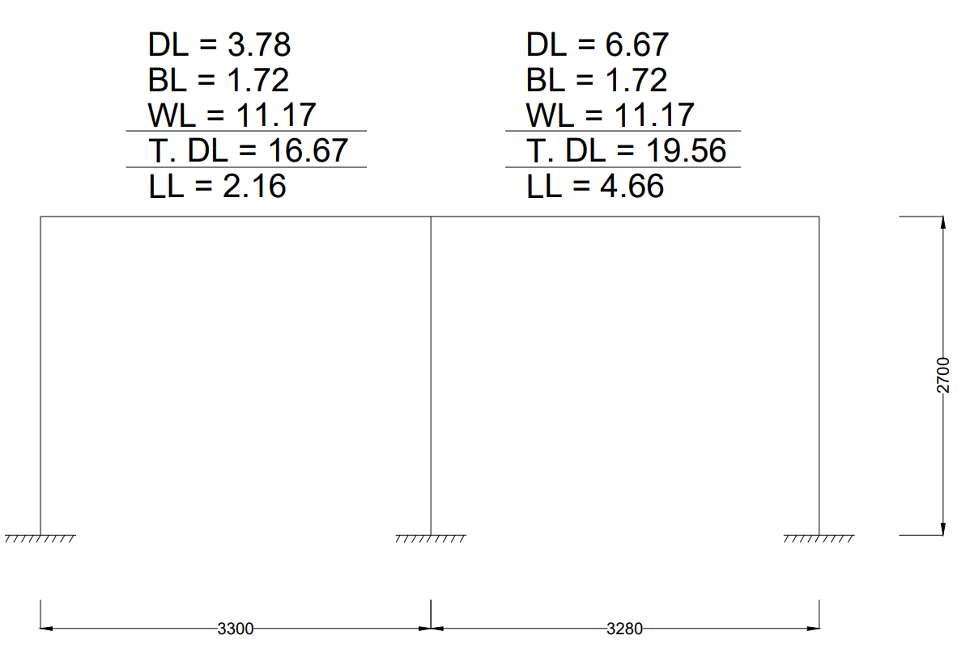
Figure 3.10: Load calculation in frame A1-A2-A3.

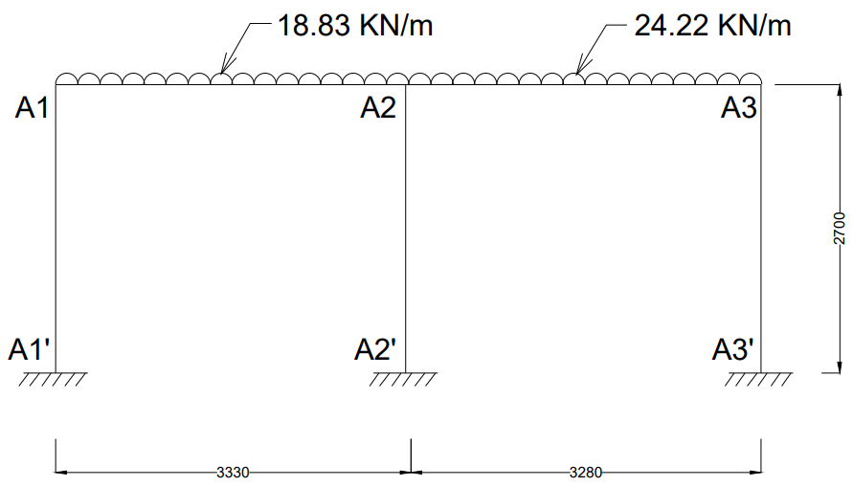
Figure 3.11: Frame A1-A2-A3 with loads.

Frame B1-B2-B3:
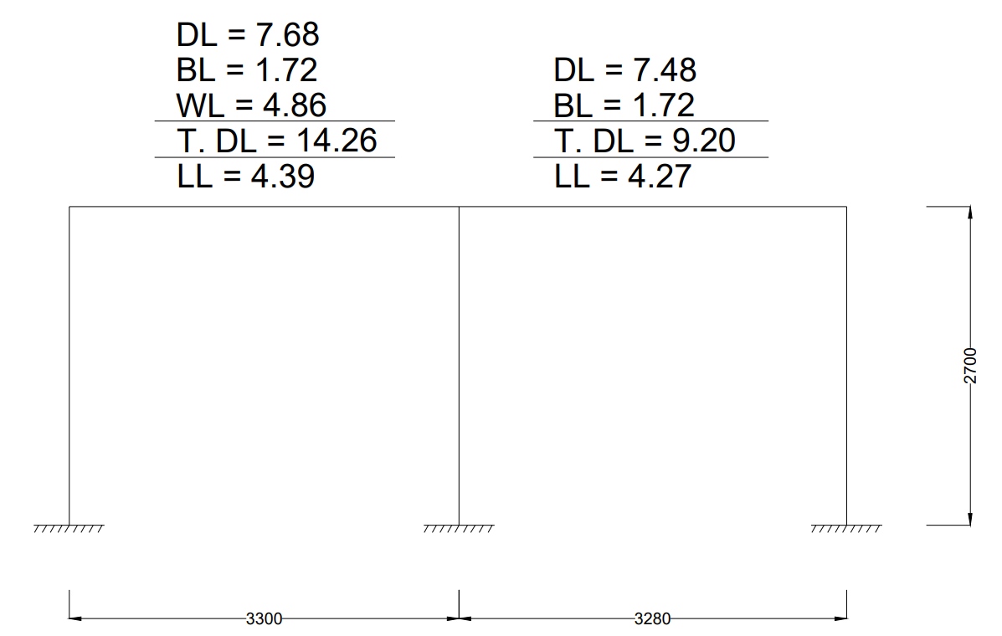
Figure 3.12: Load calculation in frame B1-B2-B3.

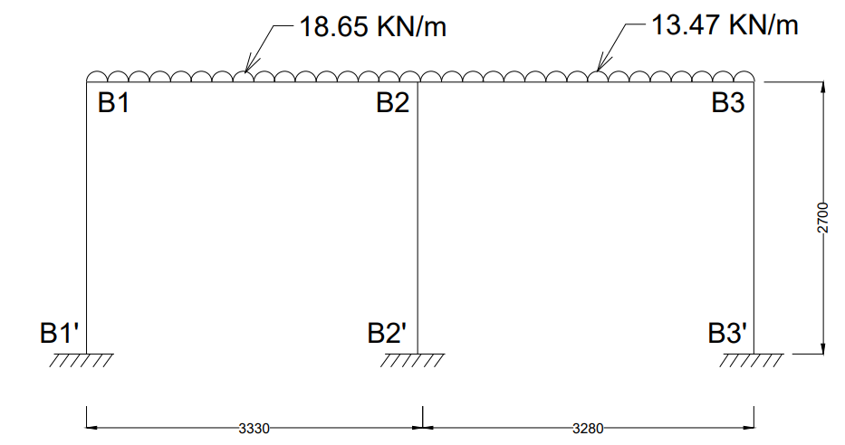
Figure 3.13: Frame B1-B2-B3 with loads.

Frame C1-C2-C3:
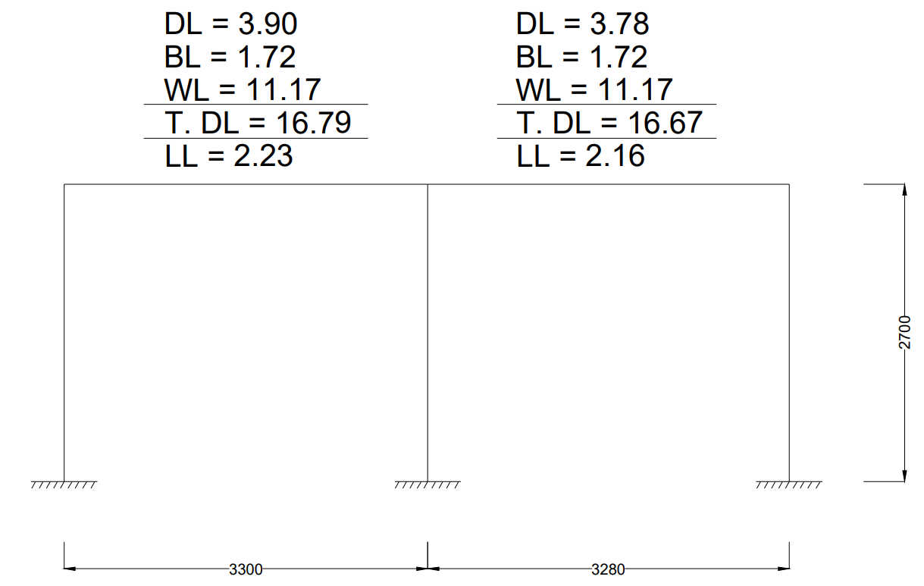
Figure 3.14: Load calculation in frame C1-C2-C3.

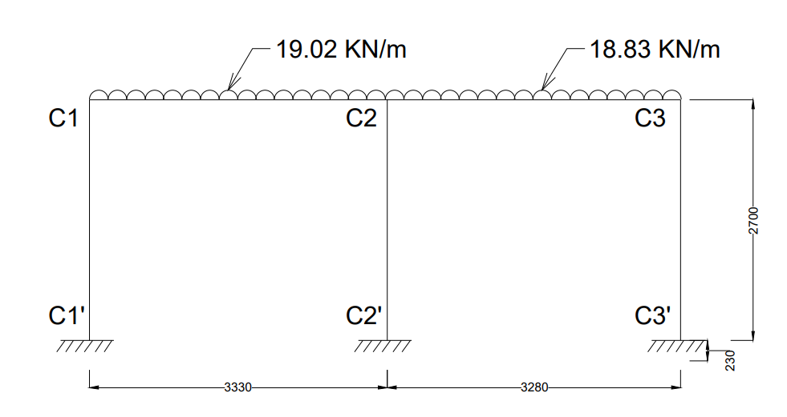
Figure 3.15: Frame C1-C2-C3 with loads.

3.5 METHODS OF ANALYSIS:

The structural analysis is a mathematical algorithm process by which the response of a structure to specified loads and actions is determined. This response is measured by determining the internal forces or stress resultants and displacements or deformations throughout the structure.

To get various forces and moments in the members (or) frames, it is necessary to analyze the frame and then designed. The following are some methods used in frame analysis.
1. Slope Deflecting Method.
2. Moment Distribution Method.
3. Kani's Method.
4. Substitute Frame Method.
5. Finite Element Method.
6. Cantilever Method.
7. Portal Method.
8. Factor Method.
9. Matrix Method.
10. Column Analogy Method.

3.5.1 Kani's Method:

Gasper Kani, a German engineer, developed another distribution procedure based on slope deflection equations. This method is very useful for the analysis of multistorey frames. The greatest advantage of this method is, even if a mistake is committed in distribution in one of the cycles, it converges finally to the correct answer. Even today, many practising engineers who are not familiar with computer methods, use Kani's method for the analysis of 3 to 4 storey building frames.
This method is first explained for structures with fixed ends. Then, the modifications to handle simply supported and overhanging ends are discussed. Analysis of symmetric frames making use of the symmetry is also explained, after which an analysis of general frames is taken up.

3.6 ANALYSIS by Kani՛s Method:

Analysis of Frame A1-B1-C1

Figure 3.16: Frame A1-B1-C1
Step 1: Fixed End Moments
MF_{A1B1} = $\frac{-{WL}^{2}}{12}$ = $\frac{-18.03 × {2.8}^{2}}{12}$ = -11.78 KN-m
MF_{B1A1} = $\frac{{WL}^{2}}{12}$ = $\frac{18.03 × {2.8}^{2}}{12}$ = +11.78 KN-m
MF_{B1C1} = $\frac{-{WL}^{2}}{12}$ = $\frac{-18.56 × {3.1}^{2}}{12}$ = -14.86 KN-m
MF_{C1B1} = $\frac{{WL}^{2}}{12}$ = $\frac{18.56 × {3.1}^{2}}{12}$ = +14.86 KN-m
Fixed end moments in All the columns are zero.
i.e,
MF_{A1A1՛ =} MF_{A1՛A1} = MF_{B1B1՛ =} MF_{B1՛B1 =} MF_{C1C1՛ =} MF_{C1՛C1} = 0

Step 2: Rotation Factor $\left(R.F = -\frac{1}{2} \left(\frac{k}{Σk}\right) \right)$, $\left(k= \frac{4EI}{L}\right)$
Joints | Members | Stiffness ($k$) | $$Σk$$ | R.F
A1 | A1B1 | 1.428EI | 2.909EI | -0.245
A1 | A1A1՛ | 1.481EI | 2.909EI | -0.255
B1 | B1A1 | 1.428EI | 4.200EI | -0.170
B1 | B1C1 | 1.290EI | 4.200EI | -0.154
B1 | B1B1՛ | 1.481EI | 4.200EI | -0.176
C1 | C1B1 | 1.290EI | 2.771EI | -0.233
C1 | C1C1՛ | 1.481EI | 2.771EI | -0.267
Table 3.2: Rotation Factor
Stiffness ($k$) $\left(k=\left(\frac{4EI}{L}\right)\right)$
K_{A1B1} = $\left(\frac{4EI}{2.8}\right)$ = 1.428EI
K_{A1A1՛} = $\left(\frac{4EI}{2.7}\right)$ = 1.481EI
K_{B1A1} = $\left(\frac{4EI}{2.8}\right)$ = 1.428EI
K_{B1C1} = $\left(\frac{4EI}{3.1}\right)$ = 1.290EI
K_{B1B1՛} = $\left(\frac{4EI}{2.7}\right)$ = 1.481EI
K_{C1B1} = $\left(\frac{4EI}{3.1}\right)$ = 1.290EI
K_{C1C1՛} = $\left(\frac{4EI}{2.7}\right)$ = 1.481EI
Sum of Stiffness ∑$k$ at Joints
A1: 1.428EI + 1.481EI = 2.909EI
B1: 1.428EI + 1.290EI + 1.481EI = 4.200EI
C1: 1.290EI + 1.481EI = 2.771EI
Rotation Factor $\left(R.F = -\frac{1}{2} \left(\frac{k}{Σk}\right) \right)$
R.F_{A1B1} = $-\frac{1}{2} \left(\frac{1.428EI}{2.909EI}\right)$ = -0.245
R.F_{A1A1՛} = $-\frac{1}{2} \left(\frac{1.481EI}{2.909EI}\right)$= -0.255
R.F_{B1A1} = $-\frac{1}{2} \left(\frac{1.428EI}{4.200EI}\right)$ = -0.170
R.F_{B1C1} = $-\frac{1}{2} \left(\frac{1.290EI}{4.200EI}\right)$ = -0.154
R.F_{B1B1՛} = $-\frac{1}{2} \left(\frac{1.481EI}{4.200EI}\right)$ = -0.176
R.F_{C1B1} = $-\frac{1}{2} \left(\frac{1.290EI}{2.771EI}\right)$ = -0.233
R.F_{C1C1՛} = $-\frac{1}{2} \left(\frac{1.481EI}{2.771EI}\right)$ = -0.267

Step 3: Displacement Factor $\left(D.F = -\frac{3}{2} \left(\frac{k}{Σk}\right) \right)$
Storey | Members | $$k$$ | $$Σk$$ | D.F
1 | A1A1՛ | 1.481EI | 4.444EI | -0.5
1 | B1B1՛ | 1.481EI | 4.444EI | -0.5
1 | C1C1՛ | 1.481EI | 4.444EI | -0.5
Table 3.3: Displacement Factor
Stiffness ($k$) $\left(k=\left(\frac{4EI}{L}\right)\right)$
K_{A1A1՛} = $\left(\frac{4EI}{2.7}\right)$ = 1.481EI
K_{B1B1՛} = $\left(\frac{4EI}{2.7}\right)$ = 1.481EI
K_{C1C1՛} = $\left(\frac{4EI}{2.7}\right)$ = 1.481EI
Sum of Stiffness ∑$k$ at Storey
∑$k$ = 1.481EI + 1.481EI + 1.481EI = 4.444EI
Displacement Factor $\left(D.F = -\frac{3}{2} \left(\frac{k}{Σk}\right) \right)$
D.F_{A1A1՛} = $-\frac{3}{2} \left(\frac{1.481EI}{4.444EI}\right)$= -0.5
D.F_{B1B1՛} = $-\frac{3}{2} \left(\frac{1.481EI}{4.444EI}\right)$ = -0.5
D.F_{C1C1՛} = $-\frac{3}{2} \left(\frac{1.481EI}{4.444EI}\right)$ = -0.5

Rotation and Displacement Contribution

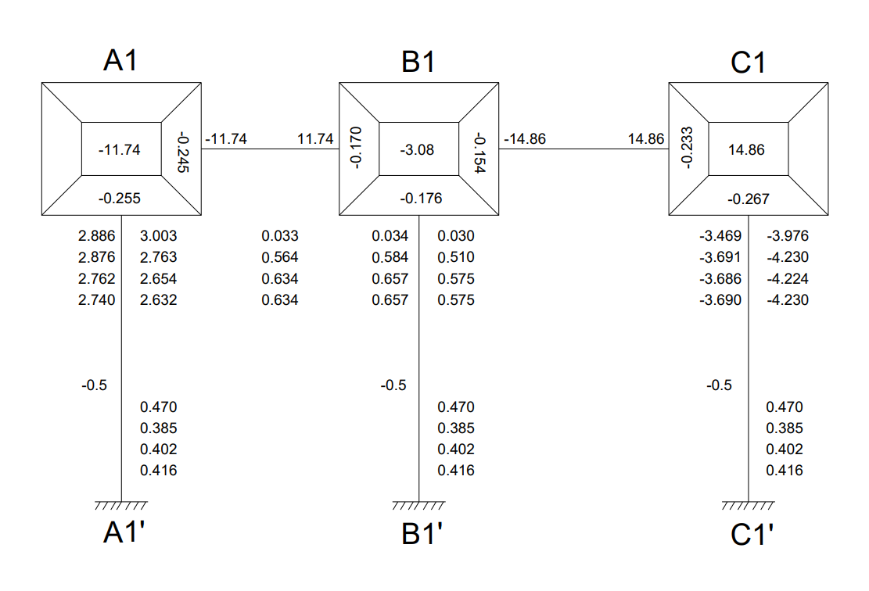
Figure 3.17: Rotation and Displacement Contribution

Cycle 1
Joint Rotation $\left(C.V. = R.F × \left[∑FEM+NCV+FCV\right]\right)$
M_{A1B1} = -0.245 × [-11.78 + 0 + 0] = 2.886
M_{A1A1՛} = -0.255 × [-11.78 + 0 + 0] = 3.003
M_{B1A1} = -0.170 × [-3.08 + 2.886 + 0] = 0.033
M_{B1C1} = -0.154 × [-3.08 + 2.886 + 0] = 0.030
M_{B1B1՛} = -0.176 × [-3.08 + 2.886 + 0] = 0.034
M_{C1B1} = -0.233 × [14.86 + 0.030 + 0] = -3.469
M_{C1C1՛} = -0.267 × [14.86 + 0.030 + 0] = -3.976

Displacement Contribution
For All Columns $\left(R.V. = D.F × \left[∑Rotations Contribution at Columns\right]\right)$
M_{A1A1՛} + M_{B1B1՛} + M_{C1C1՛} = -0.5 $×$ (3.003 + 0.034 + (-3.976)) = 0.470

Cycle 2
Joint Rotation $\left(C.V. = R.F × \left[∑FEM+NCV+FCV\right]\right)$
M_{A1B1} = -0.245 × [-11.78 + 0.470 + 0.033] = 2.763
M_{A1A1՛} = -0.255 × [-11.78 + 0.470 + 0.033] = 2.876
M_{B1A1} = -0.170 × [-3.08 + 0.470 + 2.763 + (-3.469)] = 0.564
M_{B1C1} = -0.154 × [-3.08 + 0.470 + 2.763 + (-3.469)] = 0.510
M_{B1B1՛} = -0.176 × [-3.08 + 0.470 + 2.763 + (-3.469)] = 0.584
M_{C1B1} = -0.233 × [14.86 + 0.470 + 0.510] = -3.691
M_{C1C1՛} = -0.267 × [14.86 + 0.470 + 0.510] = -4.230

Displacement Contribution
For All Columns $\left(R.V. = D.F × \left[∑Rotations Contribution at Columns\right]\right)$
M_{A1A1՛} + M_{B1B1՛} + M_{C1C1՛} = -0.5 $×$ (2.876 + 0.584 + (-4.230)) = 0.385

Cycle 3
Joint Rotation $\left(C.V. = R.F × \left[∑FEM+NCV+FCV\right]\right)$
M_{A1B1} = -0.245 × [-11.78 + 0.385 + 0.564] = 2.654
M_{A1A1՛} = -0.255 × [-11.78 + 0.385 + 0.564] = 2.762
M_{B1A1} = -0.170 × [-3.08 + 0.385 + 2.654 + (-3.691)] = 0.634
M_{B1C1} = -0.154 × [-3.08 + 0.385 + 2.654 + (-3.691)] = 0.575
M_{B1B1՛} = -0.176 × [-3.08 + 0.385 + 2.654 + (-3.691)] = 0.657
M_{C1B1} = -0.233 × [14.86 + 0.385 + 0.575] = -3.686
M_{C1C1՛} = -0.267 × [14.86 + 0.385 + 0.575] = -4.224

Displacement Contribution
For All Columns $\left(R.V. = D.F × \left[∑Rotations Contribution at Columns\right]\right)$
M_{A1A1՛} + M_{B1B1՛} + M_{C1C1՛} = -0.5 $×$ (2.762 + 0.657 + (-4.224)) = 0.4025

Cycle 4
Joint Rotation $\left(C.V. = R.F × \left[∑FEM+NCV+FCV\right]\right)$
M_{A1B1} = -0.245 × [-11.78 + 0.4025 + 0.634] = 2.632
M_{A1A1՛} = -0.255 × [-11.78 + 0.4025 + 0.634] = 2.740
M_{B1A1} = -0.170 × [-3.08 + 0.4025 + 2.632 + (-3.686)] = 0.634
M_{B1C1} = -0.154 × [-3.08 + 0.4025 + 2.632 + (-3.686)] = 0.575
M_{B1B1՛} = -0.176 × [-3.08 + 0.4025 + 2.632 + (-3.686)] = 0.657
M_{C1B1} = -0.233 × [14.86 + 0.4025 + 0.575] = -3.690
M_{C1C1՛} = -0.267 × [14.86 + 0.4025 + 0.575] = -4.230

Displacement Contribution
For All Columns $\left(R.V. = D.F × \left[∑Rotations Contribution at Columns\right]\right)$
M_{A1A1՛} + M_{B1B1՛} + M_{C1C1՛} = -0.5 $×$ (2.740 + 0.657 + (-4.230)) = 0.4165

Step 4: Final End Moments
M_{ij} = FEM + 2×M_{ij} (Near end Rotation) + M_{ji} (Far end Rotation) +M՛՛ (Displacement)

Beams (No Sway M՛՛= 0)
M_{A1B1} = -11.78 + 2(2.632) + 0.634 = -5.88
M_{B1A1} = 11.78 + 2(0.634) + 2.632 = 15.68
M_{B1C1} = -14.86+ 2(0.575) + (-3.690) = -17.40
M_{C1B1} = 14.86 + 2(-3.690) + 0.575 = 8.05

Column (With Sway M՛՛= 0.4165)
M_{A1A1՛} = 0 + 2(2.740) + 0 + 0.4165 = 5.89
M_{A1՛A1} = 0 + 2(0) + 2.740 + 0.4165 = 3.15
M_{B1B1՛} = 0 + 2(0.657) + 0 + 0.4165 = 1.73
M_{B1՛B1} = 0 + 2(0) + 0.657 + 0.4165 = 1.07
M_{C1C1՛} = 0 + 2(-4.230) + 0 + 0.4165 = -8.04
M_{C1՛C1} = 0 + 2(0) + (-4.230) + 0.4165 = -3.81

Equilibrium Check
Joint A1 = M_{A1B1} + M_{A1A1՛} = -5.88 + 5.89 = 0.01 ≈ 0
Joint A1 = M_{B1A1} + M_{B1C1՛ +} M_{B1B1՛} = 15.68 + (-17.40) + 1.73 = 0.01 ≈ 0
Joint A1 = M_{C1B1} + M_{C1C1՛} = 8.05 – 8.04 = 0.01 ≈ 0
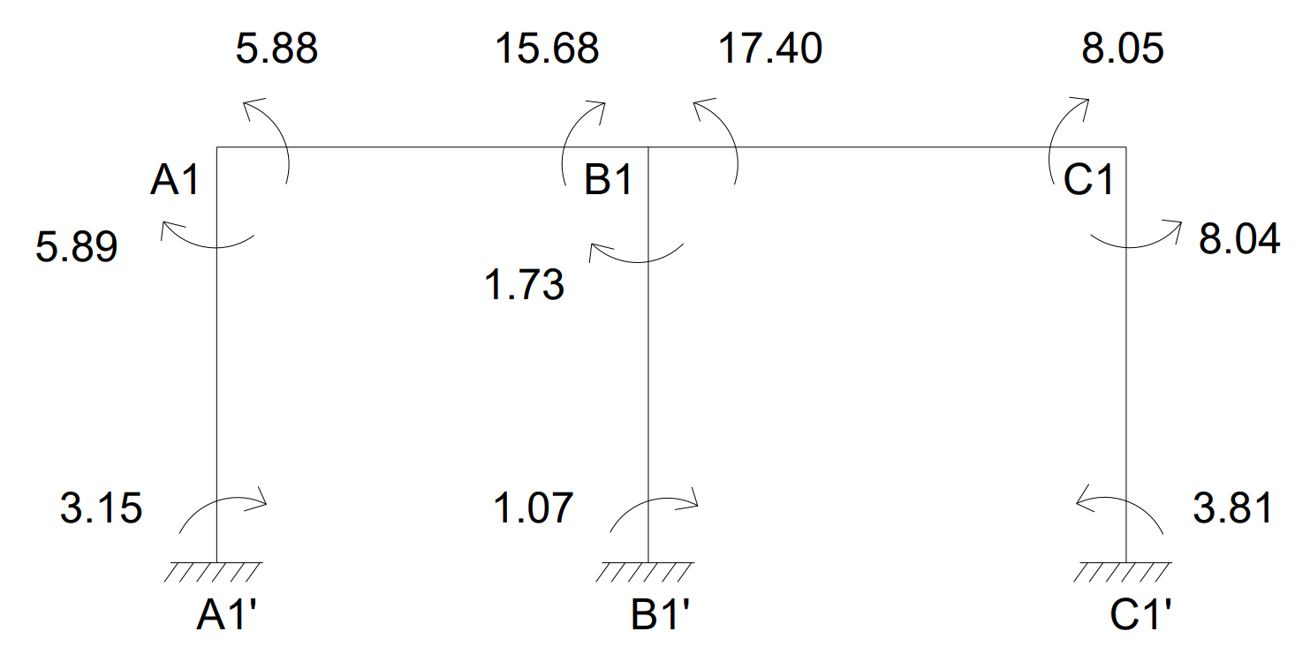
Figure 3.18: Final End Moments

CALCULATION BENDING MOMENT
BM_{A1B1} = $\frac{{WL}^{2}}{8}$ = $\frac{{18.03 ×2.8}^{2}}{8}$ = 17.67KN-m
BM_{B1C1} = $\frac{{WL}^{2}}{8}$ = $\frac{{18.56 ×3.1}^{2}}{8}$ = 22.30KN-m
BENDING MOMENT DIAGRAM
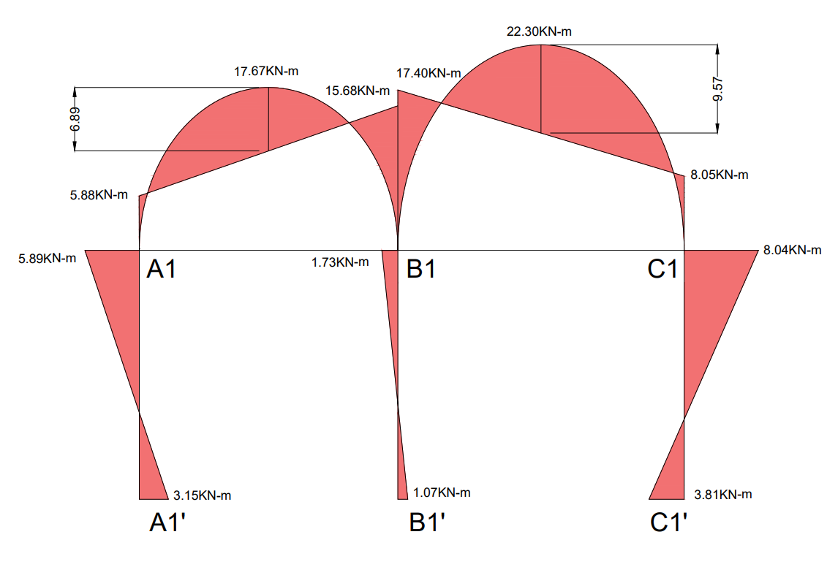
Figure 3.19: Bending Moment Diagram
CALCULATION OF REACTIONS

SPAN A1-B1
Length (L) = 2.8m, UDL (W) = 18.03KN/m
Simply Supported Reactions:
R_{total} = $\frac{WL}{2}$ = $\frac{18.03 ×2.8}{2}$ = 25.24KN
Reaction Due to End Moments:
R_{moments} = $\frac{M_{B1A1}- M_{A1B1}}{L}$ = $\frac{15.68- 5.88}{2.8}$ = 3.50KN
Final Reactions:
R_{A1} = R_{total} – R_{moments} = 25.24 – 3.50 = 21.74KN
R_{B1(Left)} = R_{total} + R_{moments} = 25.24 + 3.50 = 28.74KN

SPAN B1-C1
Length (L) = 3.1m, UDL (W) = 18.56KN/m
Simply Supported Reactions:
R_{total} = $\frac{WL}{2}$ = $\frac{18.56 ×3.1}{2}$ = 28.77KN
Reaction Due to End Moments:
R_{moments} = $\frac{M_{B1C1}- M_{C1B1)}}{L}$ = $\frac{17.40- 8.05}{3.1}$ = 3.02KN
Final Reactions:
R_{B1(Right)} = R_{total} + R_{moments} = 28.77 + 3.02 = 31.79KN
R_{C1}= R_{total} – R_{moments} = 28.77 – 3.02 = 25.75KN
Total Reactions:
Reaction at Column A1 (R_{A1}) = 21.74KN
Reaction at Column B1 (R_{B1}) = R_{B1(Left)} + R_{B1(Right)} = 28.74 + 31.79 = 60.53KN
Reaction at Column C1 (R_{C1}) = 25.75KN
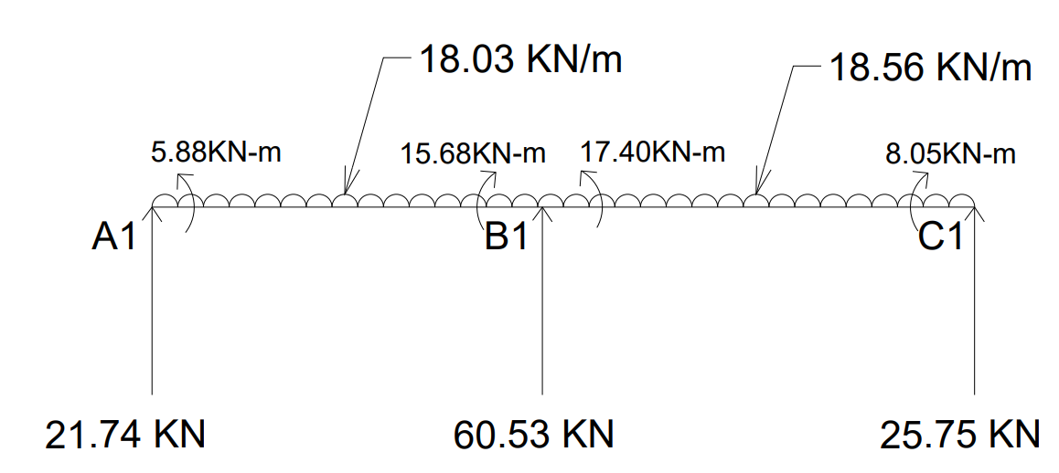
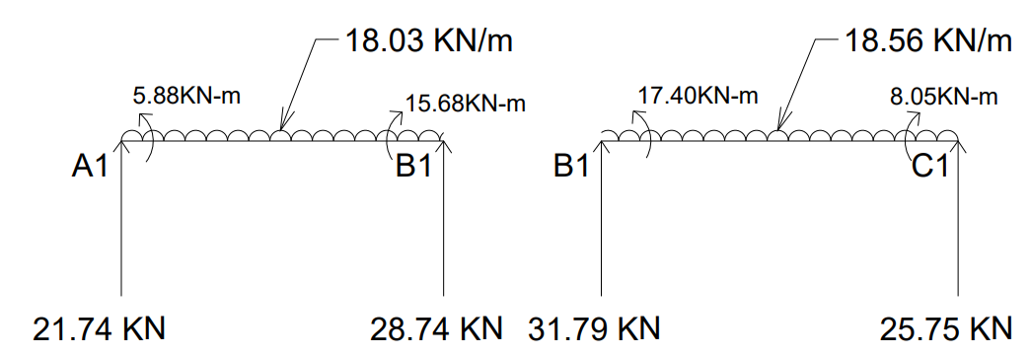
Figure 3.20: Reactions

Shear Force:
At C1 = 25.75
At B1 = 25.75 - 18.56 × 3.1 = -31.79
= -31.79 + 60.53 = 28.74
At A1 = 25.75 + 60.53 – 18.56 × 3.1 – 18.03 × 2.8 = -21.74
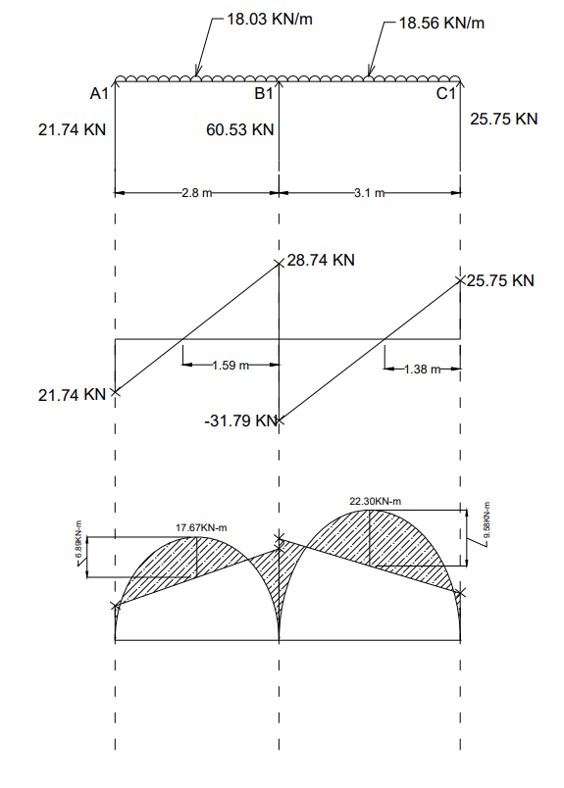
Figure 3.21: Bending Moment and Shear Force Diagram of A1-B1-C1

Analysis of Frame A2-B2-C2
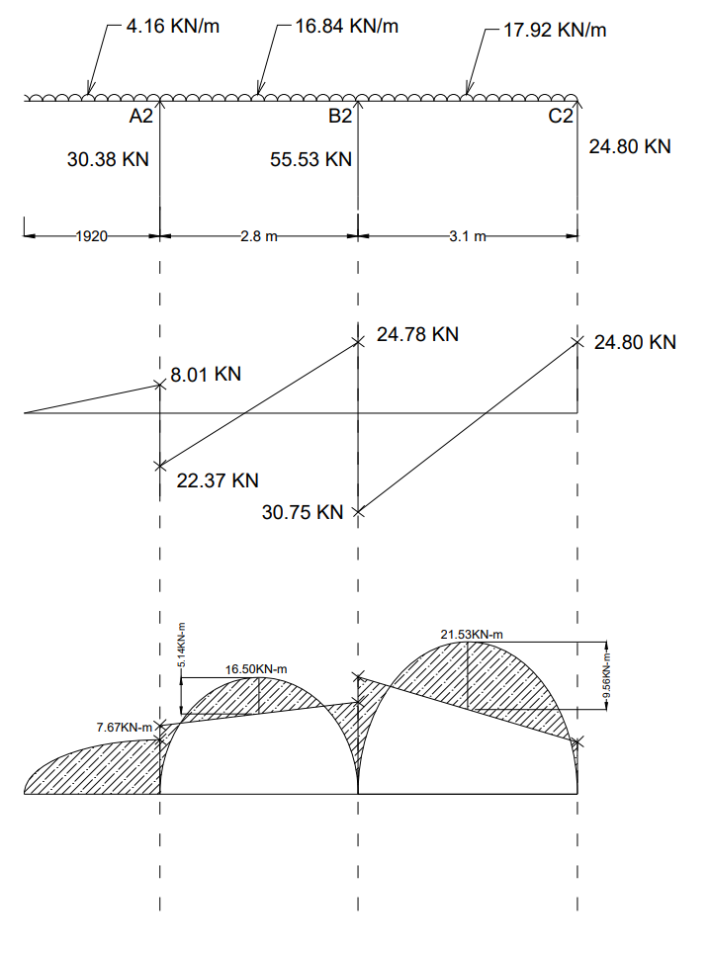
Figure 3.22: Bending Moment and Shear Force Diagram of A2-B2-C2
Analysis of Frame A3-B3-C3
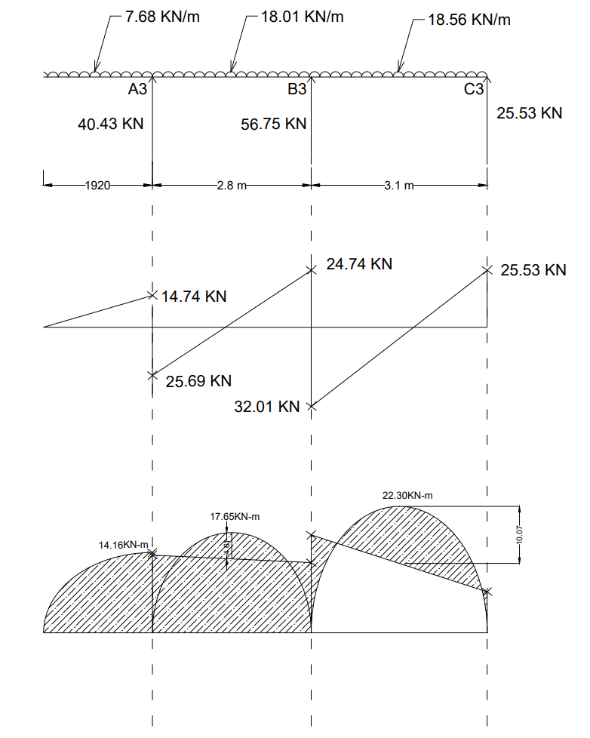
Figure 3.23: Bending Moment and Shear Force Diagram of A3-B3-C3
Analysis of Frame A1-A2-A3
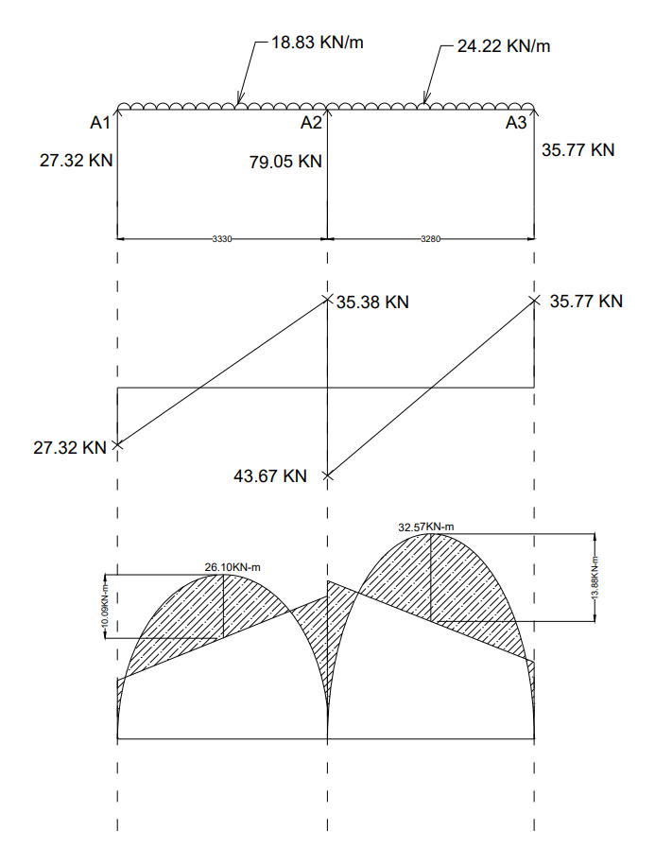
Figure 3.24: Bending Moment and Shear Force Diagram of A1-A2-A3
Analysis of Frame B1-B2-B3
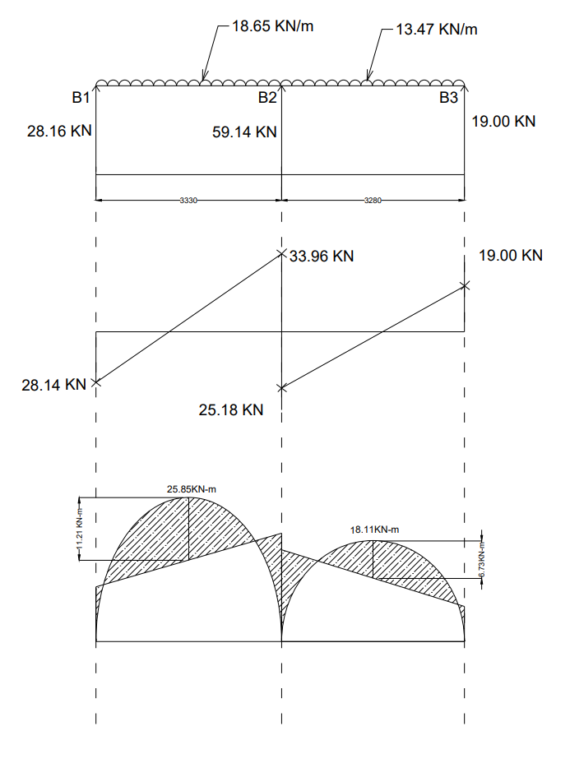
Figure 3.25: Bending Moment and Shear Force Diagram of B1-B2-B3

Analysis of Frame C1-C2-C3

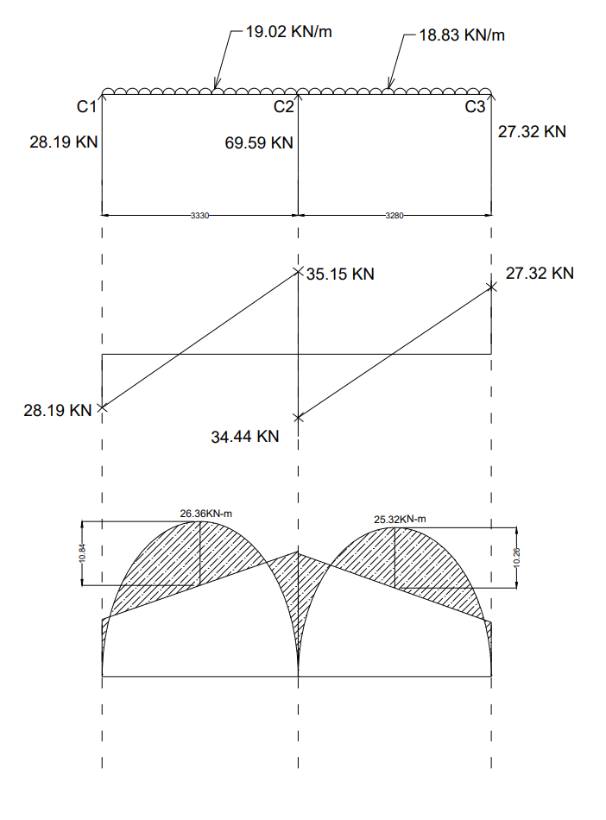
Figure 3.26: Bending Moment and Shear Force Diagram of C1-C2-C3

CHAPTER 4
DESIGNING
4.1 METHODS OF DESIGN OF REINFORCED CONCRETE:
The aim of design is to decide the size of the member and amount of reinforcement required, so that the structure will perform satisfactorily during its life period with minimum cost. The following three methods have been developed for the design of reinforced concrete structures.
- Working stress method
- Ultimate load method
- Limit state method
4.1.1 Working stress method:
Working stress method is based on elastic theory assuming reinforced concrete as elastic material. The stress strain curve of concrete is assumed as linear from zero at the neutral axis to a maximum value at the extreme fiber.
This method adopts permissible stresses which are obtained by dividing ultimate stress by a factor known as factor of safety. For concrete a factor of safety of 3 is used and for steel it is 1.78. This factor of safety account for any uncertainties in estimation of working loads and variation in material properties.
In working stress method, the structural member is designed for working loads such that the stresses developed are within the allowable stress. Hence, the failure criterion is the stress. This method is simple and reasonably reliable.
The drawbacks of this method are
- Stress strain curve for concrete is assumed as linear, which is not true.
- Factor of safety does not predict the true margin of safety.
- The failure criteria assumed is stress but strain criteria is the reliable.
- The effect of the creep and shrinkage of the concrete is ignored.
- This method gives uneconomical section.

This method has been deleted in IS: 456-2000, but the concept of this method is retained for checking the serviceability state of deflections and cracking. Hence, the knowledge of this method is essential and IS: 456-2000 gives it in the appendix.

4.1.2 Ultimate load method:
In ultimate load method, structural elements are designed for ultimate loads which are obtained by multiplying the working loads with a factor known as load factor. Hence, the designer can able to predict the excess load the structure can carry beyond the working load without collapse. Hence, this method gives the true margin of safety. This method considers the actual stress strain curve of concrete and the failure criteria is assumed as ultimate strain.
This method gives very economical sections. However it leads to excessive deformation and cracking. Thus, this method is failed to satisfy the serviceability and durability requirements. To overcome these drawbacks, the limit state method has been developed to take care of both strength and serviceability requirements.
4.1.3 Limit state method:
In the limit state method, the structural elements are designed for ultimate load and checked for serviceability (deflection, cracking etc) at working loads so that the structure is fit for use throughout its life period. The details of this method are given in article 2.1.
4.2 PHILOSOPHY OF LIMIT STATE DESIGN:
A structure may become unfit for use not only when it collapse but when it violates the serviceability requirements such as deflection, cracking etc. the philosophy of limit state method of design is to see that the structure remains fit for use throughout its life period by assuring safety against strength and serviceability requirements i.e. the structure will not reach the limit state in its life time. The acceptable limit for safety against strength and serviceability requirements before failure occurs is called limit state. All the relevant limit state has to be considered in the design. The load and strength of the materials are to be estimated by probabilistic approach (characteristic values). The design loads and strengths are derived from the characteristic values through the use of partial safety factors.
4.2.1 Limit states:
The various limit states to be considered in the design are
- Limit state of collapse
- Limit state of serviceability
Limit state of collapse:
It is the limit state at which the structure is likely to collapse. The structure may collapse due to rupture of one or more critical sections or loss of overall stability due to buckling or overturning. This limit state may correspond to

- Flexure
- Compression
- Shear
- torsion
Limit state of serviceability:
Limit state serviceability relate to the performance of the structure at working loads. It is the limit state at which the structure undergone excessive deflection, which adversely affect the finishes causing discomfort to the users and excessive cracking which effects the efficiency or appearance of the structure.
This limit state may correspond to
- deflection
- cracking
- other limit states (vibrations, fire resistance, durability)

4.2.2 Characteristic strength of materials:
The characteristic strength of material is that value of the strength of the material below which not more than 5% of the test results are expected to fall.
For concrete, characteristic strength is compressive strength of 150 mm cubes of 28 days in N/mm2, below which not more than 5% of the test results are expected to fall. Concrete grade are specified based on this strength.
For steel, the minimum yield strength or 0.2% proof strength is taken as the characteristic strength of steel.
4.2.3 Characteristic loads:
The maximum working load that the structure has to withstand and for which it has to be designed is called characteristic load. The characteristic loads are calculated based on statistical analysis.
As per code, the characteristic load is defined as that value of load which has 95% probability of not being exceeded during the life of the structure.
As statistical data of loads is not available, dead loads given in IS:875 (Part-1), imposed loads given in IS:875 (Part-2),wind loads given in IS:875 (Part-3), snow loads given in IS:875 (Part-4) and seismic forces given in IS:1893 shall be assumed as the characteristic loads as per IS:456-2000.

4.2.4 Design value and partial safety factors:
Materials: the design strength of materials is obtained by dividing the characteristic strength by a factor known as partial safety factor. The partial safety factor takes in to account variation of material strength, local weakness etc.
The design strength of the materials, is given by
$$Design strength=\frac{Characteristic strength}{partial safty factor }$$
Material | Limit state of collapse | Limit state of serviceability
Steel | 1.15 | 1.0
Concrete | 1.5 | 1.0
Table 4.1: Partial safety factor for material strength

Loads: design loads or factored loads, for which the structure is to be designed, are obtained by multiplying the characteristic load with a factor known as partial safety factor. The partial safety factor takes in to account inaccurate assessment of load, unexpected stress redistribution and variation in dimensional accuracy.
Load combination | Limit state of collapse |  |  | Limit state of serviceability
 | DL | LL | WL | DL | LL | WL
DL+LL | 1.5 | 1.5 | - | 1.0 | 1.0
DL+WL | 1.5 or 0.9 | - | 1.5 | 1.0 | - | 1.0
DL+LL+WL | 1.2 | 1.2 | 1.2 | 1.0 | 0.8 | 0.8

Table 4.2: Partial safety factor for loads

4.3 CODE OF PRACTICE FOR R.C.C. DESIGN:
All reinforced concrete structural design in our country should conform to the revised Indian standard code IS: 456-2000, code of practice for plain and reinforced concrete (Forth revision).
The Bureau of Indian Standards have released over the years several hand books to facilitate reinforced concrete structural designers to design routine structural elements quickly by referring to the various tables and graphs presented in the hand books.

The following hand books will serve as useful design aids for structural concrete designers.
- SP 16 – 1980 – Design aids for reinforced concrete to IS:456
- SP 24 – 1983 – Explanatory hand book on IS:456
- SP 34 – 1987 – Hand book on concrete reinforcement and detailing.
- SP 23 – 1982 – Hand book on concrete Mixes.

4.4 DESIGN OF ROOF SLAB:
The imposed loads on flat roofs, sloping roofs and curved roofs, due to use or occupancy of the building and the geometry of the types of roofs are given in Table -2 of IS:875(Part 2)-1987.
In our case, the imposed load on the roof slab is taken as 2 KN/m² because the access is provided to the roofs. [It is given in page. 14, table – 2, clauses 4.1 of IS 875(part -2) – 1987]
For designation point of view, the roof slabs are named S1, S2, S3, and S4. Since each slab panel in our layout has unique dimensions (2.8m x 3.3m, 3.1m x 3.3m, 2.8m x 3.28m, and 3.1m x 3.28m), there are no symmetrical groups, and each will be designed individually as shown in the figure below. The slab thickness is taken as 100mm.
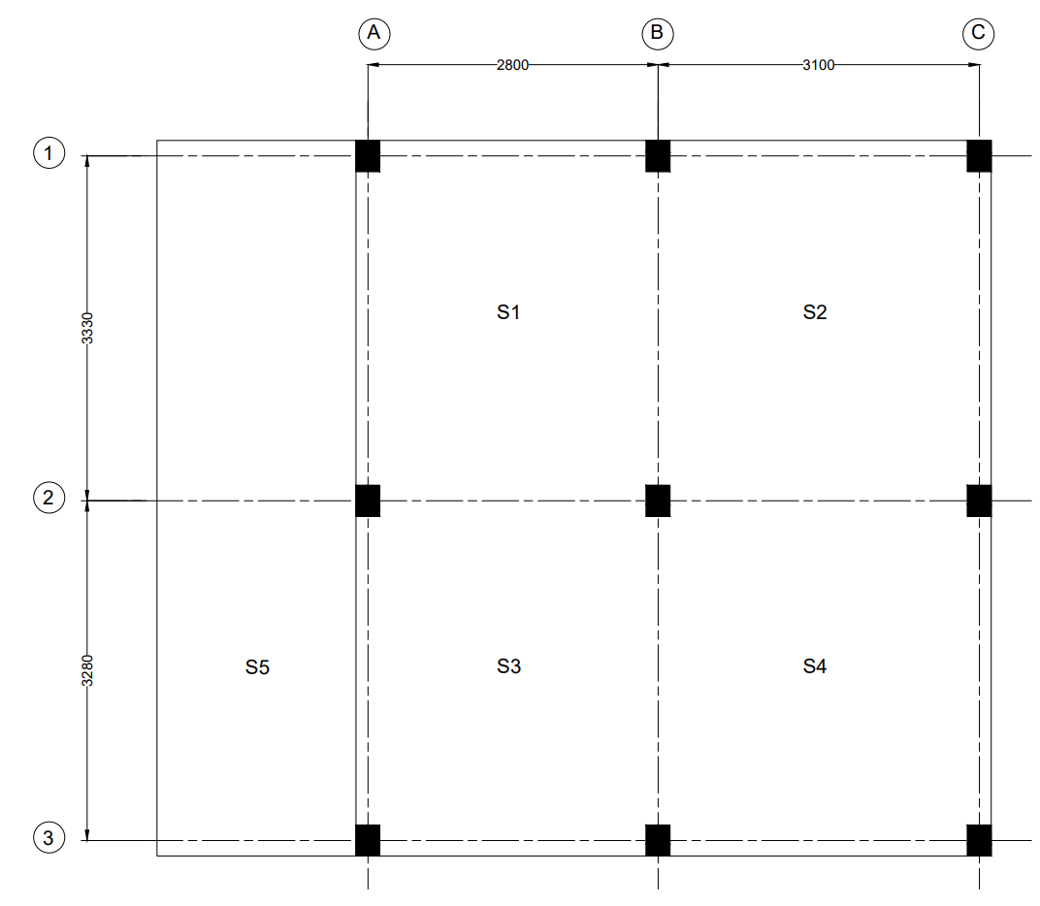
Figure 4.1: Floor Slab.

DESIGN OF SLAB [S1]:

As per Ratio,
L_{X} = 2800 mm
L_{Y} = 3330 mm

$\frac{Ly}{Lx}$ = $\frac{3330}{2800}$ =$1.19<2$

So the slab should be design as two way slab
Assuming the Depth:
Overall depth of the slab = d_{o} = 100 mm
Diameter of the bar in Shorter Span directions = 8 mm
Diameter of the bar in Longer directions = 8 mm
Clear cover = 15 mm
Code limits:

As per IS 456-2000 Overall depth of the slab should be greater of the following

- d_{o} > 100 mm
So it is satisfied.
Diameter of the bar:

The diameter of reinforcing bar shall not exceed one eight of the total thickness of the slab witch is given in page No.48 of IS - 456-2000 in article 26.5.2.2.

Maximum diameter of the bar =$\frac{1}{8}$ d_{o}
=$\frac{1}{8}$ x 100
= 12.5 mm > 8 mm

Maximum Dia of the bar > selected Dia bar
*So let us adopt 8mm dia bar
Effective depth:
d _{(short)} = 100 - 15 - $\frac{8}{2}$ = 81 mm
d _{(longer)} = 100 - 15 - 8 - $\frac{8}{2}$ = 73 mm

EFFECTIVE LENGTH:
Shorter span:
[ Given in page No.34 of IS - 456-2000 in article 22.2(a).]
It should be least of the following
(Clear Span= 2800-230= 2570mm)
- Clear span + Half of the bearing on either side of the slab
[Bearing = 230mm]
= $\frac{230}{2}$ + 2570 + $\frac{230}{2}$
= 2800 mm
- Clear span + Effective Depth
= 2570 + 81
= 2651 mm
*So take Effective length = 2651mm
Longer span:
[ Given in page No.34 of IS - 456-2000 in article 22.2(a).]
It should be least of the following
(Clear Span= 3330-230= 3100mm)
- Clear span + Half of the bearing on either side of the slab
[Bearing = 230 mm]
= $\frac{230}{2}$ + 3100 + $\frac{230}{2}$
= 3330 mm
- Clear span + Effective Depth
= 3100 + 73
= 3173 mm
*So take Effective length = 3173 mm

LOADS ON THE SLAB:
As per IS – 875 (Part – 2) – 1987, the imposed loads on the roof slab is taken as 2 KN /m² where the access is provided to the roofs.
[It is given in page. 14, table – 2, cause 1(a) of IS 875(part -2) – 1987]

Self weight of the slab = 1 x 1 x 0.100 x 25
= 2.5 KN/m²
Weight of weathering course = 1 KN/m²
Imposed load = 2 KN/m²

Total Load = 5.5 KN/m²
______________________________________
Now,
Factored load = 1.5 x 5.5 = 8.25 KN/m²
FACTORED BENDING MOMENTS:
$M_{x}= ∝_{x} W l_{x}^{2}$
$M_{y}= ∝_{y} W l_{x}^{2}$
The value of $∝_{x}$ and $∝_{y}$ are given in table -26 of the IS 456- 2000 in page.no.91. This values are depends on type of panel and moment consideration.
$\frac{Ly}{Lx}$ = $\frac{3173}{2651}$ =1.196 $≅$ 1.20
$∝_{x}$= (-ve) 0.048 & (+ve) 0.036
$∝_{y}$= (-ve) 0.037 & (+ve) 0.028
$M_{ux}$ (+ve ) = 0.036 x 8.25 x (2.651)² = 2.09 KN-m
$M_{ux}$ (-ve ) = 0.048 x 8.25 x (2.651) ² = 2.78 KN-m
$M_{uy}$ (+ve ) = 0.028 x 8.25 x (2.651)² = 1.62 KN-m
$M_{uy}$ (-ve ) = 0.037 x 8.25 x (2.651)² = 2.15 KN-m

CHECK FOR DEPTH:

M_{u} = M_{u’lim}
$$M_{u} = 0.36 \frac{x_{u max}}{d} (1 - 0.42 \frac{x_{u max}}{d}) bd^{2} f_{ck}$$
For 500 grade steel, $x_{u max}$ = 0.46d which is given in page No.70 of IS - 456-2000 in article38.1.] Here maximum bending moment is considered to check the thickness.
$$2.78×{10}^{6} = 0.36 \frac{0.46d}{d} (1 - 0.42 \frac{0.46d}{d} ) 1000×d^{2} ×20$$

$d_{(required)}$ = 32.34 mm
$d_{(required)}$ < $d_{(provided)}$
So the section is safe in bending.
AREA OF REINFORCEMENT IN SLAB (A_{st}):
$+ve$ Reinforcement for shorter span:
$$M_{ux}(+ve) = 0.87 f_{y} A_{st} d (1- \frac{f_{y}A_{st} }{bd f_{ck}})$$
$$2.09 ×{10}^{6} = 0.87 × 500× A_{st}×81 (1- \frac{500×A_{st} }{1000×81× 20})$$
$$A_{st}=60.50{ mm}^{2}$$
Minimum Reinforcement:
Code limits:

As per IS 456-2000, the minimum area of steel in slab should be provided 0.12% of gross area for HYSD bars. [ It is given in page No.48 of IS - 456-2000 in article 26.5.2.1.]
$$A_{st (minimum)}=0.12\% gross area$$
$$A_{st (minimum)}=\frac{0.12}{100}×1000×100=120{ mm}^{2}$$
$$A_{st(required)}<A_{st (minimum)}$$
So provide $A_{st }$minimum…,
Spacing:

It should be lesser of the following
- $S=\frac{a_{st}}{A_{st}}×1000$ $=\frac{50.26}{120}×1000=418.83 mm$, where ($a_{st}=\frac{π}{4}×8^{2}=50.26)$
- $S=3d=3×81=243$
- $S=300mm$
Let us provide 8mm diameter HYSD bars at 240mm c/c. [$A_{st(provided)}=209.41 {mm}^{2}$]
$-ve$ Reinforcement for shorter span:
$$M_{ux}(-ve) = 0.87 f_{y} A_{st} d (1- \frac{f_{y}A_{st} }{bd f_{ck}})$$
$$2.78×{10}^{6} = 0.87 × 500× A_{st}×81 (1- \frac{500×A_{st} }{1000×81× 20})$$
$$A_{st}=81.25{ mm}^{2}$$
$$A_{st(required)}<A_{st (minimum)}$$
So provide $A_{st }$minimum…,

Spacing:

It should be lesser of the following
- $S=\frac{a_{st}}{A_{st}}×1000$ $=\frac{50.26}{120}×1000=418.83 mm$, where ($a_{st}=\frac{π}{4}×8^{2}=50.26)$
- $S=3d=3×81=243$
- $S=300mm$
Let us provide 8mm diameter HYSD bars at 240mm c/c.
$+ve$ Reinforcement for longer span:
$$M_{uy}(+ve) = 0.87 f_{y} A_{st} d (1- \frac{f_{y}A_{st} }{bd f_{ck}})$$
$$1.62 ×{10}^{6} = 0.87 × 500× A_{st}×73 (1- \frac{500×A_{st} }{1000×73× 20})$$
$$A_{st}=51.92{ mm}^{2}$$
Code limits:

As per IS 456-2000, the minimum area of steel in slab should be provided 0.12% of gross area for HYSD bars. [ It is given in page No.48 of IS - 456-2000 in article 26.5.2.1.]
$$A_{st (minimum)}=0.12\% gross area$$
$$A_{st (minimum)}=\frac{0.12}{100}×1000×100=120{ mm}^{2}$$
$$A_{st(required)}<A_{st (minimum)}$$
So provide $A_{st }$minimum…,
Spacing:
It should be least of the following
- $S=\frac{a_{st}}{A_{st}}×1000$ $=\frac{50.26}{120}×1000=418.83 mm$, where ($a_{st}=\frac{π}{4}×8^{2}=50.26)$
- $S=3d=3×73=219 mm$
- $S=300mm$
Let us provide 8mm diameter HYSD bars at 210 mm c/c. [$A_{st(provided)}=239.33 {mm}^{2}$]
$-ve$ Reinforcement for longer span:
$$M_{uy}(-ve) = 0.87 f_{y} A_{st} d (1- \frac{f_{y}A_{st} }{bd f_{ck}})$$
$$2.15×{10}^{6} = 0.87 × 500× A_{st}×73 (1- \frac{500×A_{st} }{1000×73× 20})$$
$$A_{st}=69.45{ mm}^{2}$$
$$A_{st(required)}<A_{st (minimum)}$$
So provide $A_{st }$minimum…,
Spacing:
It should be least of the following
- $S=\frac{a_{st}}{A_{st}}×1000$ $=\frac{50.26}{120}×1000=418.83 mm$, where ($a_{st}=\frac{π}{4}×8^{2}=50.26)$
- $S=3d=3×73=219 mm$
- $S=300mm$
Let us provide 8mm diameter HYSD bars at 210 mm c/c.
CHECK FOR DEFLECTION:
Basic value for two-way slab is given in page.39, article 24.1 of IS 456-2000.
Basic value (BV) = 40
% of Steel = Pt =$\frac{A_{st}}{bd}×100$= $\frac{209.41}{1000 ×81}×100=0.26\%$
Based on Pt value take modification factor (MF) from code IS 456-2000 in page. 38
$$f_{s }=0.58×500×\frac{120}{209.41} =166.18 N/{mm}^{2}$$
MF = 2
$d_{(required)}$ = $\frac{leff}{BV×MF}=\frac{2651}{40×2}=33.13mm$
$d_{(required)}$ < $d_{(provided)}$
So the section is safe in deflection.

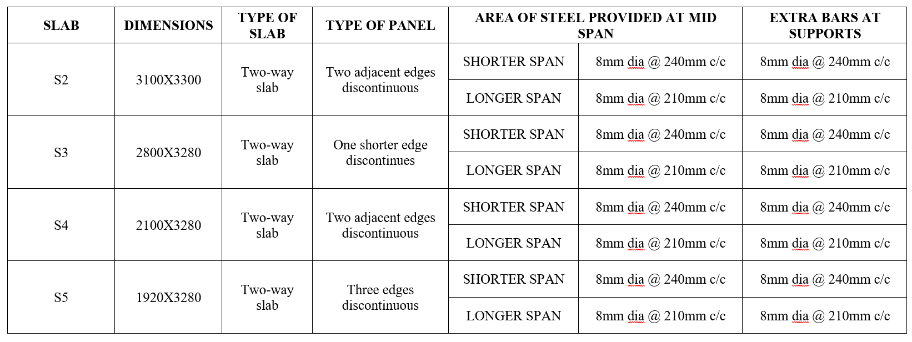
Table 4.3: Roof slab details.

4.5 DESIGN OF BEAMS:
4.5.1 BEAM:
Beam is a horizontal structural member which transmits loads horizontally along their length to the supports where the loads are generally transformed into vertical forces. The objective of Beams is to withstand vertical loads, shear forces and bending moments.
Depending on the types of supports the beams are classified as:
- Simply supported beam
- Cantilever beam
- Over hanging beam
- Continuous beam
- Fixed beam
- Propped cantilever beam
Code limitations:
In IS-456-2000-page No.48, the limitations and specifications for beam design are given as
Beams:
Tension reinforcement:
a) Minimum reinforcement -The minimum area of tension reinforcement shall be not less than that given by the following:
$$\frac{A_{s}}{bd}= \frac{0.87}{f_{y}}$$
Where,
A_{s}= minimum area of tension reinforcement,
b = breadth of beam or the breadth of the web of T-beam.
d = effective depth, and
f_{y} = characteristic strength of reinforcement in N/mm2
b) Maximum reinforcement – The maximum area of tension reinforcement shall not exceed 0.04bD.
Compression reinforcement:
The maximum area of compression reinforcement shall not exceed 0.04bD. Compression reinforcement in beams shall be enclosed by stirrups for effective lateral restraint.

Side face reinforcement:
Where the depth of the web in a beam exceeds 750mm, side face reinforcement shall be provided along the two faces. The total area of such reinforcement shall be not less than 0.1 percent of the web area and shall be distributed equally on two faces at a spacing not exceeding 300mm or web thickness whichever is less.
Transverse reinforcement in beams for shear and torsion:
The transverse reinforcement in beams shall be taken around the outer-most tension and compression bars. "In T-beams and I-beams, such reinforcement shall pass around longitudinal bars located close to the outer face of the flange
Maximum spacing of shear reinforcement:
The maximum spacing of shear reinforcement measured along the axis of the member shall not exceed 0.75d for vertical stirrups and d for inclined stirrups at 45º, where d is the effective depth of the section under consideration. In no case shall the spacing exceed 300mm.
Minimum shear reinforcement:
Minimum shear reinforcement in the form of stirrups shall be provided such that:
$$\frac{A_{sv}}{bS_{v}} ≥ \frac{0.4}{0.87f_{y}}$$
Where,
A_{sv} = total cross-sectional area of stirrup legs effective in shear.
S_{v} = stirrup Spacing along the Length of the member.
b = breadth of the beam or breadth of the web of flanged beam.
f_{y} = characteristic strength of the stirrup reinforcement in N/mm2 which shall not be taken greater than 415N/mm².
Where the maximum shear stress calculated is less than half the permissible value and in members of minor structural importance such as lintels. This provision need not be complied with.
Minimum reinforcement:
The mild steel reinforcement in either direction in slab shall not be less than 0.15percent of the total cross-sectional area. However, this value can be reduced to 0.12 percent when high strength deformed bars or welded wire fabric are used.

4.5.2 DESIGN OF CONTINUOUS BEAM IN FRAME A1-B1-C1:
ASSUMPTIONS:

Size of the beam
= 230X400mm
Effective cover = 30 mm
Grade of the concrete =M₂₀
Grade of the steel = Fe 500
f_{ck} = 20 N/m²
f_{y} = 500 N/m²

Effective depth (d)
= D - Effective cover
d = 400-30 = 370mm
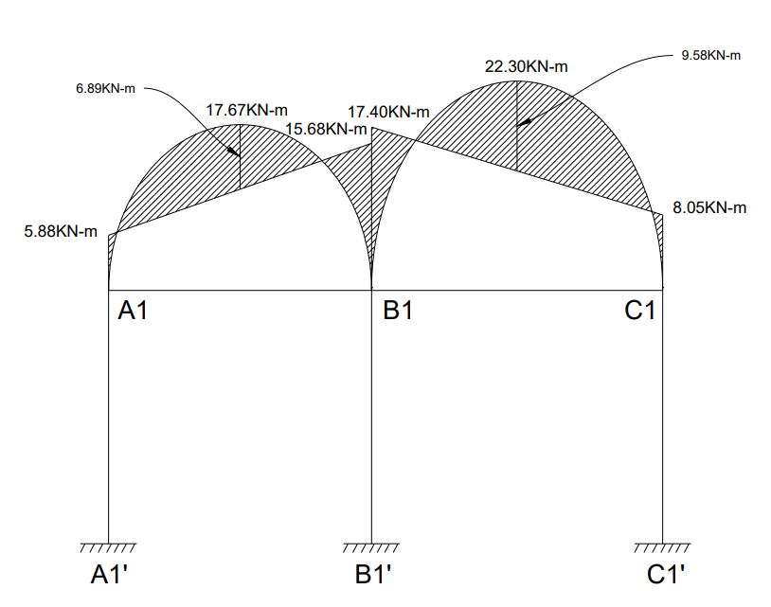
Figure 4.2: Bending moment diagram {frame A1-B1-C1}

Code limits:
As per code if Mu is less than M_{u,limit} then the section is design as a singly reinforced section otherwise it should be design as doubly reinforced section.
$$M_{u,limit} = 0.36 \frac{x_{u max}}{d} (1 - 0.42 \frac{x_{u max}}{d}) bd^{2}f_{ck}$$
$$M_{u,limit} = 0.36 \frac{0.46d}{d} (1 - 0.42 \frac{0.46d}{d} ) 230×{370}^{2} ×20$$
$$M_{u,limit} = 84.14 kN-m$$
The minimum and maximum area of steel in beam is given below [ It is given in page No.46of IS - 456-2000 in article 26.5.1.1.]
$$A_{st (minimum)}=\frac{0.85}{f_{y}} bd$$
$=\frac{0.85}{500} ×230×370=144.67{ mm}^{2}$
$$A_{st (maximum)}=0.04bD$$
$=0.04×230×400=3680 {mm}^{2}$

4.5.2.1 AREA OF THE REINFORCEMENT REQUIRED:
Let us consider BEAM A1-B1-C1:
Tension steel in span A1-B1:
$$M=6.89 kN-m$$
$$M_{u}=1.5×6.89 =10.34 kN-m$$
DEPTH REQUIRED:
M_{u} =M_{u,limit}
$$M_{u} = 0.36 \frac{x_{u max}}{d} (1 - 0.42 \frac{x_{u max}}{d}) bd^{2}f_{ck}$$
For 500 grade steel, $x_{u max}$ = 0.46d which is given in page No.70 of IS - 456-2000 in article38.1.] Here bending moment is used to check the thickness.
$$10.34×{10}^{6} = 0.36 \frac{0.46d}{d} (1 - 0.42 \frac{0.46d}{d} ) 230×d^{2} ×20$$
$d_{(required)}$ = 130 mm
$d_{(required)}$<$d_{(provided)}$
So, the section is safe in bending.
M_{u} < M_{u,limit}
So, the section is designed as singly reinforced beam.
$$M_{u}= 0.87 f_{y}A_{st} d (1- \frac{f_{y}A_{st}}{bd f_{ck}})$$
$$10.34×{10}^{6}= 0.87 × 500× A_{st}×370 (1- \frac{500×A_{st}}{230×370× 20})$$
$$A_{st}=65.50{ mm}^{2}$$
$$A_{st(required)}<A_{st (minimum)}$$
So, provide minimum $A_{st}$
Provide 2 bars of #10mm$∅$ bars {$A_{st(provided)}=157.08 {mm}^{2}$}
Tension steel in span B1-C1:
$$M=9.58 kN-m$$
$M_{u}=1.5×9.58 =14.37 kN-m$< M_{u,limit}
So, the section is designed as singly reinforced beam.

$$M_{u}= 0.87 f_{y}A_{st} d (1- \frac{f_{y}A_{st}}{bd f_{ck}})$$
$$14.37×{10}^{6}= 0.87 × 500× A_{st}×370 (1- \frac{500×A_{st}}{230×370× 20})$$
$$A_{st}=91.76{ mm}^{2}$$
$$A_{st(required)}<A_{st (minimum)}$$
So, provide minimum $A_{st}$
Provide 2 bars of #10mm$∅$ bars {$A_{st(provided)}=157.08{mm}^{2}$}
Support steel at A1:
$$M=5.88kN-m$$
$M_{u}=1.5×5.88 =8.82 kN-m$ < M_{u,limit}
So, the section is designed as singly reinforced beam.
$$M_{u}= 0.87 f_{y}A_{st} d (1- \frac{f_{y}A_{st}}{bd f_{ck}})$$
$$8.82×{10}^{6}= 0.87 × 500× A_{st}×370 (1- \frac{500×A_{st}}{230×370× 20})$$
$$A_{st}=57.74{ mm}^{2}$$
𝐴𝑠𝑡(𝑟𝑒𝑞𝑢𝑖𝑟𝑒𝑑) < 𝐴𝑠𝑡 (𝑚𝑖𝑛𝑖𝑚𝑢𝑚)
Provide 2 bar of #10mm$∅$ bar {$A_{st(provided)}=157.08 {mm}^{2}$}
Support steel at B1:
$$M=17.40 kN-m$$
$M_{u}=1.5×17.40 =26.1 kN-m<$ M_{u,limit}
So, the section is designed as singly reinforced beam.
$$M_{u}= 0.87 f_{y}A_{st} d (1- \frac{f_{y}A_{st}}{bd f_{ck}})$$
$$26.1×{10}^{6}= 0.87 × 500× A_{st}×370 (1- \frac{500×A_{st}}{230×370× 20})$$
$$A_{st}=170.72{ mm}^{2}$$
Provide 2 bar of #12mm$∅$ bar {$A_{st(provided)}=226.20 {mm}^{2}$}

Support steel at C1:
$$M=8.05 kN-m$$
$M_{u}=1.5×8.05 =12.08 kN-m$< M_{u,limit}
So, the section is designed as singly reinforced beam.
$$M_{u}= 0.87 f_{y}A_{st} d (1- \frac{f_{y}A_{st}}{bd f_{ck}})$$
$$12.08×{10}^{6}= 0.87 × 500× A_{st}×370 (1- \frac{500×A_{st}}{230×370× 20})$$
$$A_{st}=76.78{ mm}^{2}$$
$$A_{st(required)}<A_{st (minimum)}$$
So, provide minimum $A_{st}$
Provide 2 bars of #10mm$∅$ bars {$A_{st(provided)}=157.08{mm}^{2}$}
4.5.2.2 Check for deflection:
For span A1-B1:
$$d_{req}= \frac{L}{BV ×MF}$$
L = 2.8 m
The BV Value for Continuous Beam (IS – 456 – 2000, page no. 37)
BV = 26
$$P_{t}= \frac{A_{st}}{bd} ×100=\frac{157.08}{230 ×370} ×100= 0.18$$
From IS – 456 – 2000, page no. 38
$$f_{s}=0.58 ×f_{y} × \frac{Area of cross-section of steel required}{Area of cross-section of steel provided}$$

$$f_{s}=0.58 ×500 × \frac{65.50}{157.08}=120.92 N/{mm}^{2}$$
From the graph, in IS – 456 – 2000, page no. 38
MF = 2
$$d_{req}= \frac{2800}{26 ×2}=53.84<d_{prov}=370mm$$

For span B1-C1:
$$d_{req}= \frac{L}{BV ×MF}$$
L = 3.1 m
The BV Value for Continuous Beam (IS – 456 – 2000, page no. 37)
BV = 26
$$P_{t}= \frac{A_{st}}{bd} ×100=\frac{157.08}{230 ×370} ×100= 0.18$$
From IS – 456 – 2000, page no. 38
$$f_{s}=0.58 ×f_{y} × \frac{Area of cross-section of steel required}{Area of cross-section of steel provided}$$
$$f_{s}=0.58 ×500 × \frac{91.76}{157.08}=169.40 N/{mm}^{2}$$
From the graph, in IS – 456 – 2000, page no. 38
MF = 2
$$d_{req}= \frac{3100}{26 ×2}=59.61<d_{prov}=370mm$$
4.5.2.3 Design of shear reinforcement in Slab beams:
Span A1-B1:
Joint A1:
V = 21.74 KN
V_{u} = 32.61 KN
The nominal shear stress in beam of uniform depth shall be obtained by the following equation.
$τ_{v}=\frac{V_{u}}{bd}$
$=\frac{32.61 ×1000}{230×370}=0.38 N/{mm}^{2}$
$$P_{t}=\frac{A_{st}}{bd}×100$$
$$=\frac{157.08}{230×370}×100=0.18\%$$

Under no circumstances, for shear reinforcement, the nominal shear stress in beam $τ_{v}$ shall not exceed $τ_{c,max}$. [ It is given in page No.73 of IS - 456-2000 in Table No.20]

$τ_{c,max}$= 2.8 N/mm²
$τ_{v}$<$τ_{c,max}$
$τ_{c}$Value is given in page 73 of is 456: 2000. This value is depending on $P_{t}$ value and grade of concrete. For our condition M₂₀ grade and $P_{t}=0.18$ the value is given below
$$τ_{c}=0.30 N/{mm}^{2}$$
$$τ_{v}>τ_{c}$$
As per IS 456 : 2000, when the $τ_{v}$ exeed $τ_{c}$ value the shear reinforcement shall be provided.[ It is given in page No.72of IS - 456-2000 in article 40.4.]
$V_{us}=V_{u}-τ_{c}$bd
= 32.61 x 10³ – 0.3 x 230 x 370 = 7.08 KN
Shear reinforcement shall be provided to carry a shear equal to $V_{u}-τ_{c}$ bd. The strength of the shear reinforcement $V_{us}$ for vertical stirrups is given below [IS 456 : 2000, p.no.73]
$$V_{us}=\frac{{0.87 { f}_{f}A}_{sv}d}{{ s}_{v}}$$
Using 8mm, 2 legged$F_{e}$500 steel stirrups, $A_{sv}=2 × \frac{π}{4}×8^{2}=100.53{mm}^{2}$
$$S_{v}=\frac{0.87×500×100.53×370}{7.08×1000}=2285.35 mm$$
Code limits:
[ It is given in page No.47of IS - 456-2000 in article 26.5.1.5.]
It should be lesser of the following
- $S=0.75d=0.75×370=277.5mm$
- $S=300mm$
So, provide 8 mm dia stirrups at 275 mm c/c
Span A1-B1:
Joint B1:
V = 28.74 KN
V_{u} = 43.11 KN

The nominal shear stress in beam of uniform depth shall be obtained by the following equation.
$τ_{v}=\frac{V_{u}}{bd}$

$=\frac{43.11 ×1000}{230×370}=0.51 N/{mm}^{2}$
$$P_{t}=\frac{A_{st}}{bd}×100$$
$$=\frac{226.20}{230×370}×100=0.27\%$$
Under no circumstances, for shear reinforcement, the nominal shear stress in beam $τ_{v}$ shall not exceed $τ_{c,max}$. [ It is given in page No.73 of IS - 456-2000 in Table No.20]
$τ_{c,max}$= 2.8 N/mm²
$τ_{v}$<$τ_{c,max}$
$τ_{c}$Value is given in page 73 of is 456: 2000. This value is depending on $P_{t}$ value and grade of concrete. For our condition M₂₀ grade and $P_{t}=0.27$ the value is given below
$$τ_{c}=0.37 N/{mm}^{2}$$
$$τ_{v}>τ_{c}$$
As per IS 456 : 2000, when the $τ_{v}$ exeed $τ_{c}$ value the shear reinforcement shall be provided.[ It is given in page No.72of IS - 456-2000 in article 40.4.]
$V_{us}=V_{u}-τ_{c}$bd
= 43.11 x 10³ – 0.37 x 230 x 370 = 11.62 KN
Shear reinforcement shall be provided to carry a shear equal to $V_{u}-τ_{c}$ bd. The strength of the shear reinforcement $V_{us}$ for vertical stirrups is given below [IS 456 : 2000, p.no.73]
$$V_{us}=\frac{{0.87 { f}_{f}A}_{sv}d}{{ s}_{v}}$$
Using 8mm, 2 legged $F_{e}$500 steel stirrups, $A_{sv}=2 × \frac{π}{4}×8^{2}=100.53{mm}^{2}$
$$S_{v}=\frac{0.87×500×100.53×370}{11.62×1000}=1392.45mm$$
Code limits:
[ It is given in page No.47of IS - 456-2000 in article 26.5.1.5.]
It should be lesser of the following
- $S=0.75d=0.75×370=277.5mm$
- $S=300mm$
So, provide 8 mm dia stirrups at 275 mm c/c

Span B1-C1:
Joint B1:
V = 31.79 KN
V_{u} = 47.69 KN
The nominal shear stress in beam of uniform depth shall be obtained by the following equation.
$τ_{v}=\frac{V_{u}}{bd}$
$=\frac{47.69 ×1000}{230×370}=0.56 N/{mm}^{2}$
$$P_{t}=\frac{A_{st}}{bd}×100$$
$$=\frac{226.20}{230×370}×100=0.27\%$$
Under no circumstances, for shear reinforcement, the nominal shear stress in beam $τ_{v}$ shall not exceed $τ_{c,max}$. [ It is given in page No.73 of IS - 456-2000 in Table No.20]
$τ_{c,max}$= 2.8 N/mm²
$τ_{v}$<$τ_{c,max}$
$τ_{c}$Value is given in page 73 of is 456: 2000. This value is depending on $P_{t}$ value and grade of concrete. For our condition M₂₀ grade and $P_{t}=0.27$ the value is given below
$$τ_{c}=0.37 N/{mm}^{2}$$
$$τ_{v}>τ_{c}$$
As per IS 456 : 2000, when the $τ_{v}$ exeed $τ_{c}$ value the shear reinforcement shall be provided.[ It is given in page No.72of IS - 456-2000 in article 40.4.]
$V_{us}=V_{u}-τ_{c}$bd
= 47.69 x 10³ – 0.37 x 230 x 370 = 16.20 KN
Shear reinforcement shall be provided to carry a shear equal to $V_{u}-τ_{c}$ bd. The strength of the shear reinforcement $V_{us}$ for vertical stirrups is given below [IS 456 : 2000, p.no.73]
$$V_{us}=\frac{{0.87 { f}_{f}A}_{sv}d}{{ s}_{v}}$$
Using 8mm, 2 legged $F_{e}$500 steel stirrups, $A_{sv}=2 × \frac{π}{4}×8^{2}=100.53{mm}^{2}$
$$S_{v}=\frac{0.87×500×100.53×370}{16.20×1000}=998.78mm$$

Code limits:
[ It is given in page No.47of IS - 456-2000 in article 26.5.1.5.]
It should be lesser of the following
- $S=0.75d=0.75×370=277.5mm$
- $S=300mm$
So, provide 8 mm dia stirrups at 275 mm c/c
Span B1-C1:
Joint C1:
V = 25.75 KN
V_{u} = 38.63 KN
The nominal shear stress in beam of uniform depth shall be obtained by the following equation.
$τ_{v}=\frac{V_{u}}{bd}$
$=\frac{38.63 ×1000}{230×370}=0.45 N/{mm}^{2}$
$$P_{t}=\frac{A_{st}}{bd}×100$$
$$=\frac{157.08}{230×370}×100=0.18\%$$
Under no circumstances, for shear reinforcement, the nominal shear stress in beam $τ_{v}$ shall not exceed $τ_{c,max}$. [ It is given in page No.73 of IS - 456-2000 in Table No.20]
$τ_{c,max}$= 2.8 N/mm²
$τ_{v}$<$τ_{c,max}$

$τ_{c}$Value is given in page 73 of is 456: 2000. This value is depending on $P_{t}$ value and grade of concrete. For our condition M₂₀ grade and $P_{t}=0.18$ the value is given below
$$τ_{c}=0.30 N/{mm}^{2}$$
$$τ_{v}>τ_{c}$$
As per IS 456 : 2000, when the $τ_{v}$ exeed $τ_{c}$ value the shear reinforcement shall be provided.[ It is given in page No.72of IS - 456-2000 in article 40.4.]
$V_{us}=V_{u}-τ_{c}$bd
= 38.63 x 10³ – 0.30 x 230 x 370 = 13.10 KN

Shear reinforcement shall be provided to carry a shear equal to $V_{u}-τ_{c}$ bd. The strength of the shear reinforcement $V_{us}$ for vertical stirrups is given below [IS 456 : 2000, p.no.73]
$$V_{us}=\frac{{0.87 { f}_{f}A}_{sv}d}{{ s}_{v}}$$
Using 8mm, 2 legged $F_{e}$500 steel stirrups, $A_{sv}=2 × \frac{π}{4}×8^{2}=100.53{mm}^{2}$
$$S_{v}=\frac{0.87×500×100.53×370}{13.10×1000}=1235.14 {mm}^{2}$$
Code limits:
[ It is given in page No.47of IS - 456-2000 in article 26.5.1.5.]
It should be lesser of the following
- $S=0.75d=0.75×370=277.5mm$
- $S=300mm$
So, provide 8 mm dia stirrups at 275 mm c/c
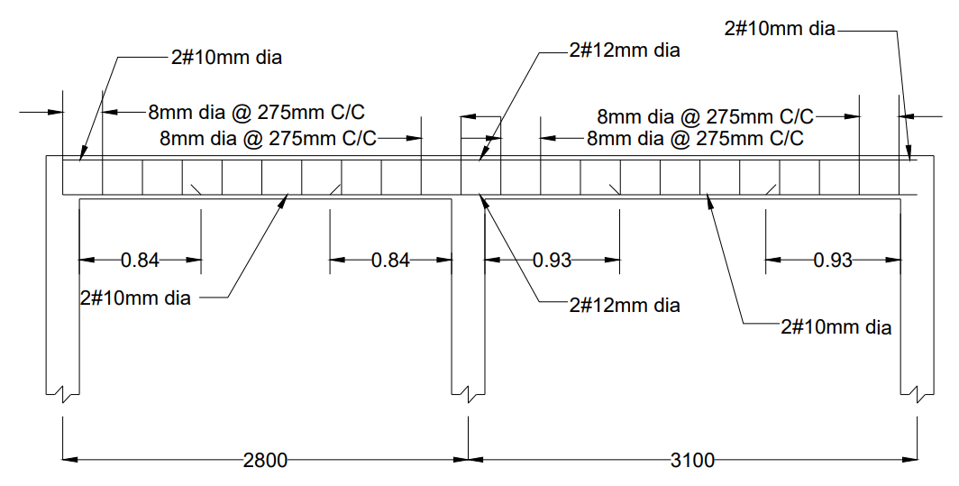
Figure 4.3: Reinforcement details of beam A1-B1-C1.

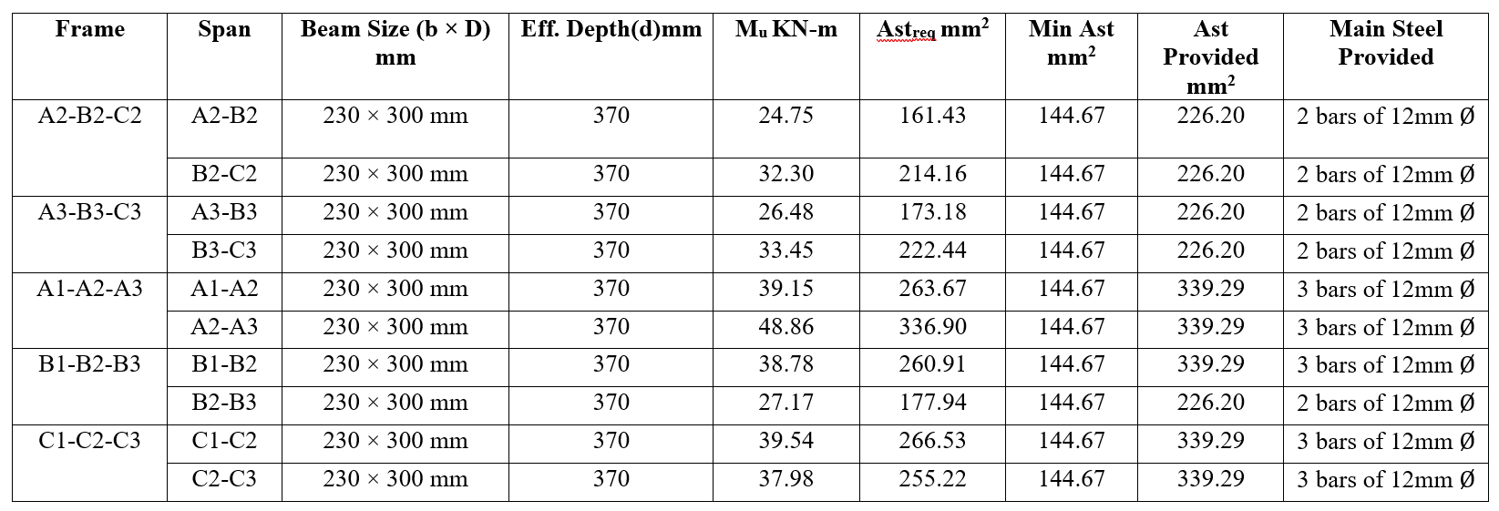
Table 4.4: Design of Main Reinforcement

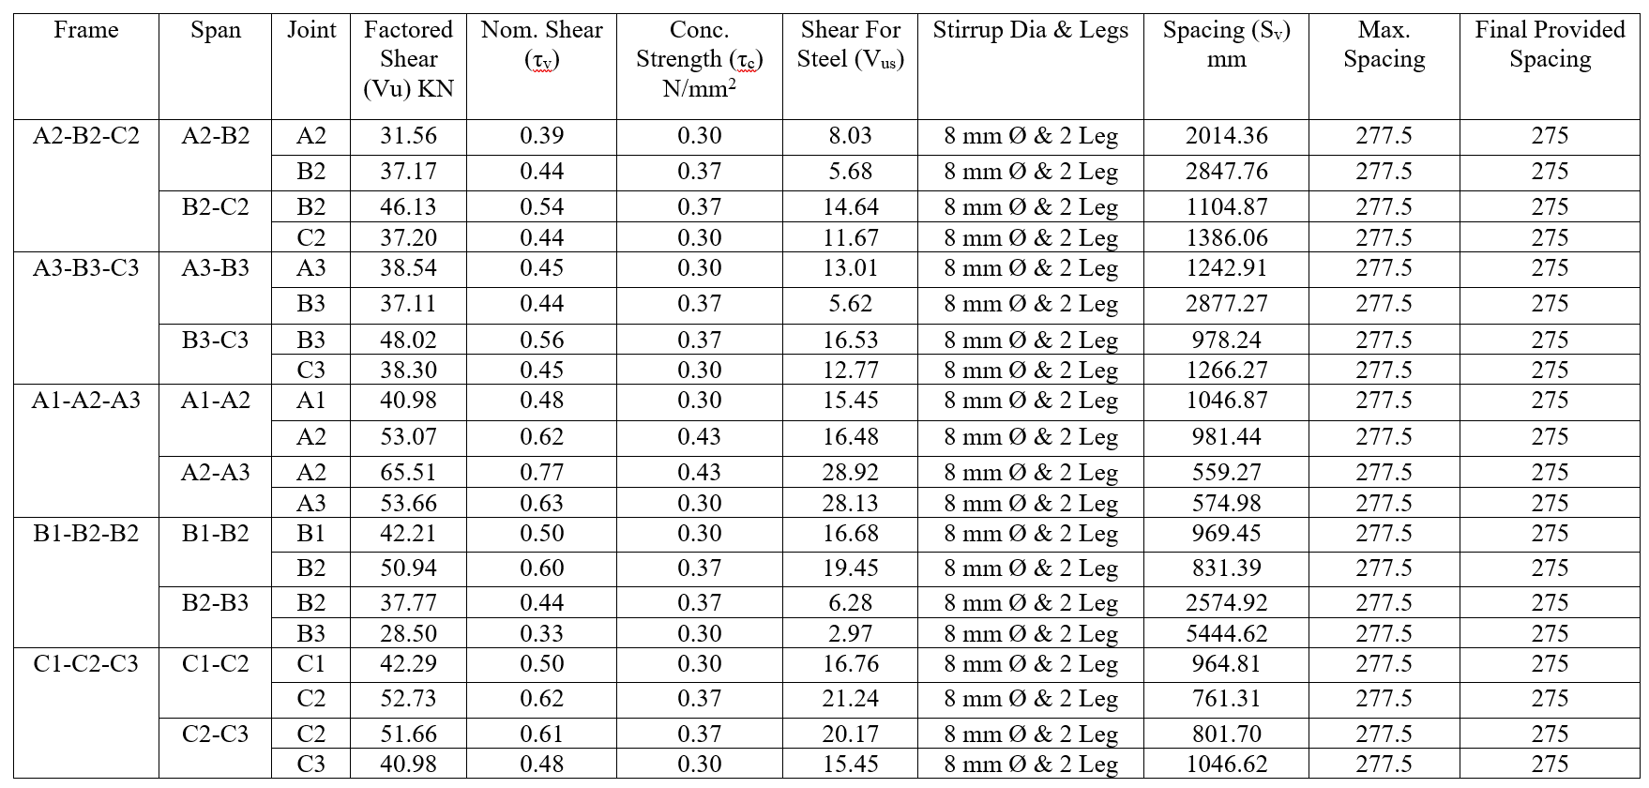
Table 4.5: Design of Shear Reinforcement (Stirrups

4.6 COLUMN DESIGN:
4.6.1 COLUMN:
It is a vertical structural member which transfers the compressive loads for, the ceiling. Roof, slab or beam, to the foundation.
It is constructed for, the materials like bricks, stones, timber, steel and other materials which have better compressive strength.
There are numerous types of columns available on basis of shape, type, loading type and slenderness ratio reinforcement.
Column type based on slenderness ratio:
- Short Column: if the ratio of effective length to the least lateral dimension is greater than 12 then it is called as long column.
- Long Column: if the ratio of effective length to the least lateral dimension is less than 12 then it is called as short column.
Column type based on type based on type of loading:
- Axially loaded column: The column which is subjected to loads acting along the longitudinal axis or centroid of the section is called as axially loaded column.
- Eccentrically loaded column: Loads which do not act on the longitudinal axis of the column is called as eccentrically loaded column.
Eccentrically loaded columns are then sub-divided into two types:
- Uni-axial column: if the eccentricity is with respect to either X-axis or Y-axis then the column is said to be under uni-axial loading.
- Bi-axial column: if the eccentricity is with respect to both X-axis and Y-axis then the column is said to be under bi-axial loading.

the types of columns used for column design are shown in the figure below.
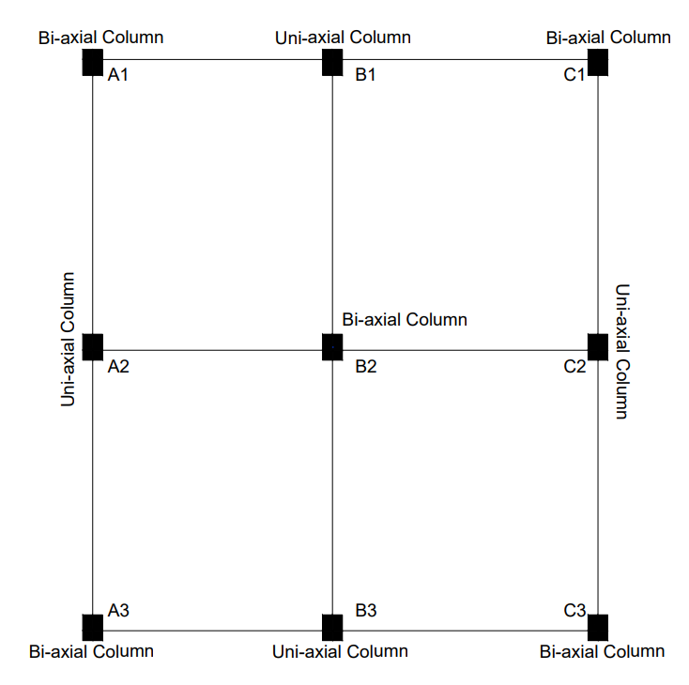
Figure 4.4: Classification of column based on position and loading.

4.6.2 Code limitations:
The limitations and specifications for column design, given in IS-456-2000, page No.48 are
Column:
longitudinal reinforcement:
- The cross-sectional area of longitudinal reinforcement shall not be less than 0.8 percent nor more than 6 percent of the gross cross-sectional area of the column.
- In any column that has a larger cross-sectional area than that required to support the load, the minimum percentage of steel shall be based upon the area of concrete required to resist the direct stress and not upon the current area.
- The minimum number of longitudinal bars provided in to column shall be rectangular in four columns and sic in circular columns.
- The bars shall not be less than 12 mm in diameter.
- Spacing of longitudinal bars measured along the periphery of the column shall not exceed 300 mm.
- In case of pedestals in which the longitudinal reinforcement is not taken in account in calculations, rated strength longitudinal reinforcement not less as 0.15 percent of the cross-sectional area shall be provided.

Pitch and diameter of lateral ties:
- Pitch- The pitch of transverse reinforcement shall be not more than the least of the following distances:
- The least lateral dimension of the compression members,
- Sixteen times the smallest diameter of the longitudinal reinforcement bar to be tied, and
- 300 mm.
- Diameter – the diameter of the polygonal links side or ties shall be not less as one fourth of the largest longitudinal bar. And in no case less than 16 mm.

4.6.3 A1 column – storey-I (Bi-axial Bending):
Size of the column = 230 x 300 mm
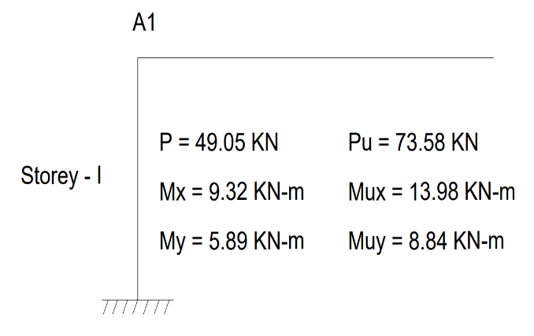
Concrete mix = M₂₀
Characteristics strength of reinforcement = 500N/mm²
Factor Load (P_{u}) = 73.58 KN
Factor moment acting parallel to the
large dimension, mix = 13.98 KN-m
Factor moment acting parallel to the Figure 4.5: Total Loads and moments on A1 column.
short dimension, mix = 8.84 KN-m
Reinforce is distributed equally on four side
Gross Area (A_{g}) = 230 × 300 = 69000 mm²
Required Minimum Steel: 0.008 × 69000 = 552 mm²
First, we assume a trial reinforcement area. Let's provide 4 bars of 16 mm diameter.
Area of Steel Provided (A_{sc}) = 4 × 201 = 804 mm²
Assuming % of steel P = 1.17 %
Area of Concrete (A_{c}): A_{g} – A_{sc} = 69000 – 804 = 68196 mm²

Assuming Effective Cover = 40mm
Reinforcement Ratio:
$$\frac{P}{f_{ck}}= \frac{1.17}{20}=0.058$$
Axial Load Ratio:
$$\frac{P_{u}}{f_{ck}.b.D}= \frac{73.58×{10}^{3}}{20 ×230×300}=0.053$$

Calculate Ultimate Axial Load Capacity
P_{uz} = 0.45f_{ck}A_{c} + 0.75f_{y}A_{sc}
P_{uz} = (0.45 × 20 × 68196) + (0.75 × 500 × 804)
P_{uz} = 915264N = 915.264KN
$\frac{P_{u}}{P_{uz}}= \frac{73.58}{915.264}$ = 0.080
According to IS 456 Table 10.2 (or SP-16 Chart 64), because 0.080 ≤ 0.2, the value of α_{n} = 1.0.
Determine Uniaxial Moment Capacities (M_{uxl}) & (M_{uyl})
Capacity about the Major Axis XX (M_{uxl})
Cover Ratio: $\frac{d^{'}}{D}$ = $\frac{40}{300}$ = 0.133
Referencing SP-16 Chart 48 (for Fe500, equal reinforcement on 4 sides, d'/D=0.133): Looking at the curve for $\frac{P}{f_{ck}}$ = 0.06 and $\frac{P_{u}}{f_{ck}bD^{2}}$ = 0.05, we read the moment parameter:
$$\frac{M_{uxl}}{f_{ck}bD^{2}} ≈0.070$$
M_{uxl} = 0.070 × 20 × 230 × 300² × 10⁻⁶
M_{uxl} = 28.98 KN-m
Capacity about the Minor Axis YY (M_{uyl})
Cover Ratio: $\frac{d^{'}}{b}$ = $\frac{40}{230}$ = 0.174
Referencing SP-16 Chart 48 (for Fe500, interpolating between, d'/D=0.15 and 0.20):
$$\frac{M_{uyl}}{f_{ck}Db^{2}} ≈ 0.064$$
M_{uyl} = 0.064 × 20 × 300 × 230² × 10⁻⁶
M_{uyl} = 20.31 KN-m
Check Biaxial Bending Interaction Equation
we apply Bresler's empirical formulation (IS 456 Clause 39.6) to ensure the combined stress is less than 1.0.
$${\left(\frac{M_{ux}}{M_{ux1}}\right)}^{α_{n}}+ {\left(\frac{M_{uy}}{M_{uy1}}\right)}^{α_{n}}≤1.0$$
$${\left(\frac{13.98}{28.98}\right)}^{1.0}+ {\left(\frac{8.84}{20.31}\right)}^{1.0}≤1.0$$
0.482 + 0.435 = 0.917
Final Verdict Because 0.917 ≤ 1.0, the design is SAFE.
The minimum practical reinforcement of 4 bars of 16 mm diameter (with 8 mm lateral ties at 200 mm c/c) is mathematically proven to handle your frame moments and axial loads under biaxial bending perfectly.

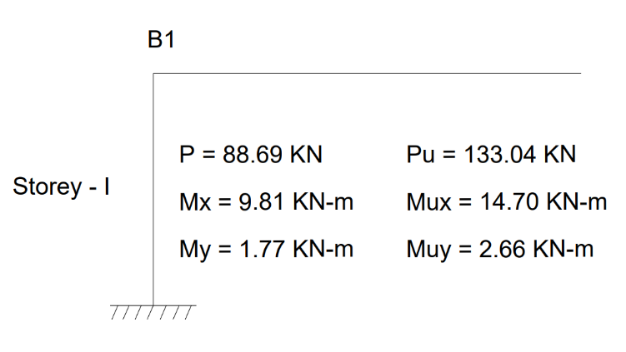
4.6.4 B1 column – storey-II (Uni-axial Bending):
Size of Column = 230 x 300
Concrete mix = M₂₀
f_{ck}= 20 N/mm²
f_{y} = 500N/mm²
Load (P) = 88.69 KN
Factor Load (P_{u}) = 133.04 KN Figure 4.6: Total Loads and moments on B1 column.
Moment in column (M) = 9.81 KN-m
Factor Moment (M_{u}) = 14.70 KN-m
Arrangement of reinforcement on Four Side
Assuming Effective cover = d’ =40mm
$$\frac{d`}{D}=\frac{40}{300}=0.133$$
Use Chart No. 44 in SP-16
$$\frac{P_{u}}{f_{ck}.b.D}= \frac{133.04 x {10}^{3}}{20x230x300}=0.096$$
$$\frac{M_{u}}{f_{ck}.b.D^{2}}= \frac{14.07 x {10}^{6}}{20x230x{300}^{2}}=0.035$$
On four Sides:
From SP-16 Refer Chart 44 for $\frac{d^{'}}{d}$= 0.1 & F_{y} = 415 N/mm²
$$\frac{P}{fck}=0.04$$
P = 0.04 x $f_{ck}$
=0.04 x 20 = 0.8%
Asc = $\frac{P}{100}xbD$ = $\frac{0.8}{100} x 230 x 300$
$A_{sc}$ = 552 mm²
Provide 4 bars of 16 mm $∅$ (Area provided = 804 mm² > 552 mm²)

Design of ties:
Diameter of ties should not less than
- (16/4) = 4 mm
- 6mm
Pitch:
[it is given in page No.49 of IS – 456 – 2000 in article 26.5.3.2]
It should be lesser of the following:
- Least lateral dimension = 230mm
- 16 x $∅$ = 16 x 16 = 256 mm
- 300mm
Hence provide 8mm $∅$ ties @ 230mm c/c.

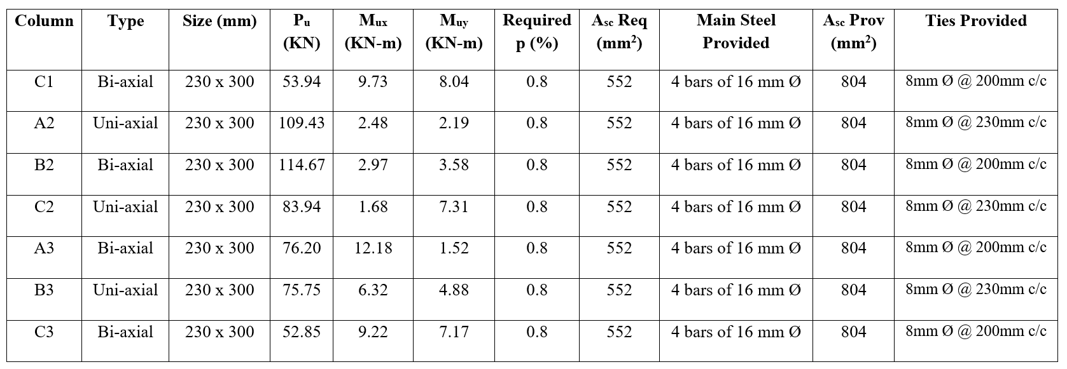
Table 4.6: Design of Columns C1, A2, B2, C2, A3, B3 & C3

4.7 FOOTING DESIGN:
Design of footing A1:
Column size = 230 x 300 mm
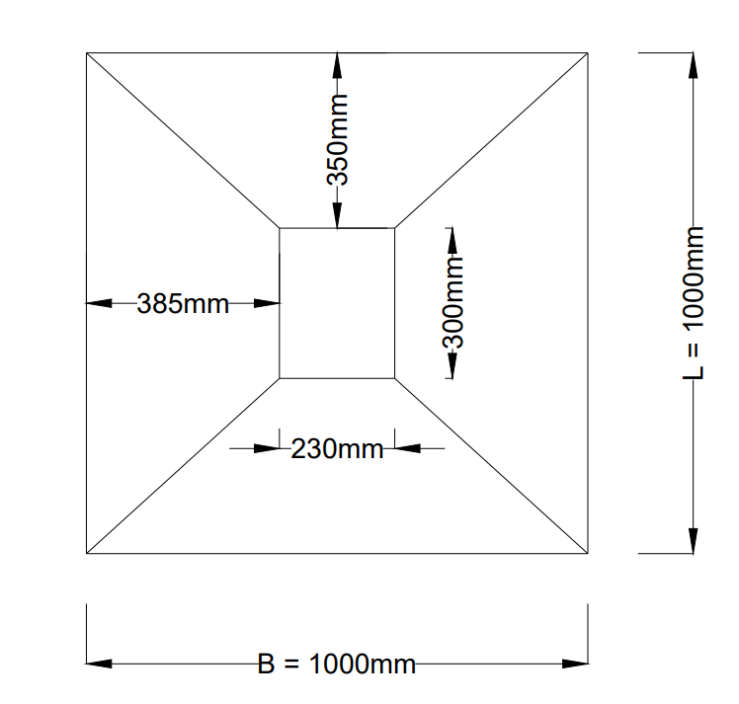
Working load of column (P) = $49.05$KN
Factored Axial load of column (P_{u}) = $73.58$KN
Grade of concrete = $M_{20}$
Grade of steel = ${Fe}_{500}$
The safe bearing capacity of soil = 200 KN/$m^{2}$
Step 1: Size of the footing:
Self-weight of footing = L = 1m, B = 1m, D=0.25m
= 2 × (1 × 1 × 0.25) × 25
= 2 × 6.25KN Figure 4.7: Area of Footing
= 12.50KN
Total load on the soil = 49.05 + 12.50 = 61.55 KN
Area of the footing = $\frac{total load}{SBC of soil }$
= $\frac{61.55}{200}$
= $0.307 m^{2}$
Since the required area of 0.307 m² is well below our assumed area of 1.0 m² (1.0 m × 1.0 m), the trial dimensions are safe.
adopt 1.0m × 1.0m rectangular footing.
Step 2: Net Upward Soil Pressure
The upward soil pressure causing bending and shear is calculated using only the factored column load (as the footing's self-weight is counteracted directly by the soil).
q_{u} = $\frac{P_{u}}{Area Provided}$ = $\frac{73.58}{1.0 ×1.0}=$73.58 KN/m²

Step 3: Bending Moment & Depth Check
The critical section for maximum bending moment lies at the face of the column.
Cantilever Projection along X-axis:
$L_{x}= \frac{1000-300}{2}$= 350 mm
Cantilever Projection along Y-axis:
$L_{y}= \frac{1000 - 230}{2}$= 385 mm
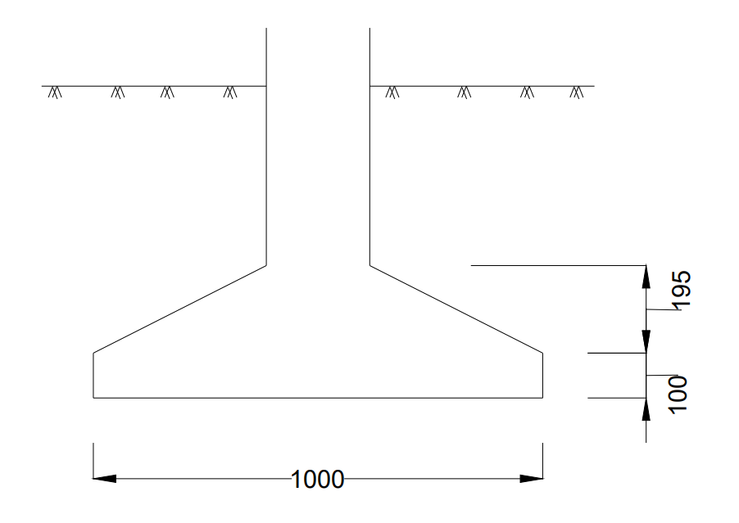
Taking the maximum projection (0.385 m) to find the governing bending moment:
$M_{u}= \frac{q_{u}× {L^{2}}_{y}}{2}= \frac{73.58 × {0.385}^{2}}{2}$= 5.45 KN-m
Minimum Depth Required for Bending (Fe500):
M_{u lim} = 0.133 × f_{ck} . B . d²
5.45 × 10⁶ = 0.133 × 20 × 1000 × d²
d = $\sqrt{\frac{5.45 × {10}^{6}}{2660}}$ = 45.2 mm
Provide a safe nominal thickness.
- Adopted Overall Depth (D): 250 mm Figure 4.8: One way Shear
- Effective Depth (d): 250 - 50 (clear cover) - 5 (half bar dia) = 195 mm

Step 4: Area of Tension Steel (IS 456 Clause 26.5.2.1)
Due to the nominal bending moment, the minimum reinforcement criteria governs.
Minimum A_{st}: 0.12% of total cross-sectional area (for HYSD bars).
A_{st}: $\frac{0.12}{100} ×1000 ×250=300{mm}^{2}$
Adopted Reinforcement: Provide 10 mm ⌀ bars at 200 mm c/c in both directions.
Area Provided (A_{st, prov}): $\frac{1000 ×78.5}{200}$ = 395 mm² (> 300 mm² , hence Safe)

Step 5: Check for One-Way Shear (IS 456 Clause 34.2.4.1.a)
The critical section is at a distance 'd' (195 mm) from the column face.
Projection beyond critical section: 385 – 195 = 190 mm
Factored Shear Force (V_{u1}): q_{u} × (0.19 × 1.0) = 73.58 × 0.19 = 13.98 KN
Nominal Shear Stress (τ_{v}): $\frac{V_{u1}}{b.d}$ = $\frac{13.98 × {10}^{3}}{1000 ×195}$ = 0.071 N/mm²
Permissible Shear Stress (τ_{c}) from IS 456 Table 19:
Percentage of steel (p_{t}): $\frac{392.5}{1000 ×195} ×100$ = 0.20%
For M20 concrete and p_{t} = 0.20%, τ_{c} = 0.32 N/mm²
Verdict: Since τ_{v}(0.071) < τ_{c}(0.32), the section is SAFE in one-way shear.

Step 6: Check for Two-Way / Punching Shear (IS 456 Clause 34.2.4.1.b & 31.6.3)
The critical section is at a distance '$\frac{d}{2}$' (97.5 mm) around the column.
Dimensions of Critical Section: (300 + 195) × (230 + 195) = 495 mm × 425 mm
Perimeter(b₀): 2 × (495 + 425) = 1840 mm²
Area of Critical Section: 0.495 × 0.425 = 0.21 m²
Factored Punching Force(V_{u2}): q_{u} × (Total area – Critical area)
= 73.58 × (1.0 – 0.21) = 58.13 KN
Punching Shear Stress (τ_{v}): $\frac{V_{u2}}{b_{0}.d}$ = $\frac{58.13 × {10}^{3}}{1840 ×195}$ = 0.162 N/mm²
Permissible Punching Shear Stress (k_{s} . τ՛_{c}):
k_{s} = (0.5 + β_{c}) where β_{c} = $\frac{230}{300}$ = 0.76
k_{s} = (0.5 + 0.76) = 1.26 (Since k_{s} > 1, we take k_{s} = 1.0)
τ՛_{c} = $0.25 \left(\sqrt{f_{ck}}\right)$ = $0.25 \left(\sqrt{20}\right)$ = 1.118 N/mm²
Permissible limit = 1.0 × 1.118 = 1.118 N/mm²
Verdict: Since τ_{v} (0.162) < 1.118 N/mm², the section is SAFE against punching shear.

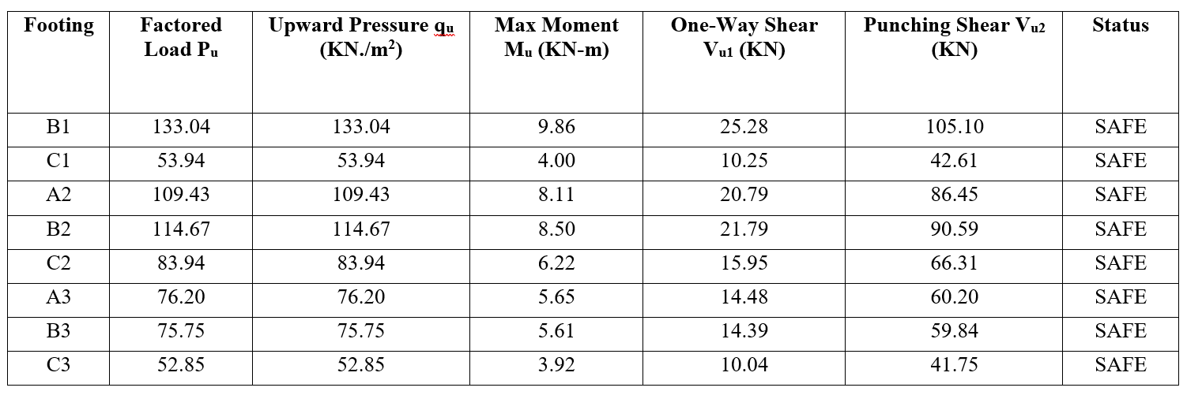
Table 4.7: Design of footing B1, C1, A2, B2, C2, A3, B3 & C3

4.8 STAIRCASE DESIGN:
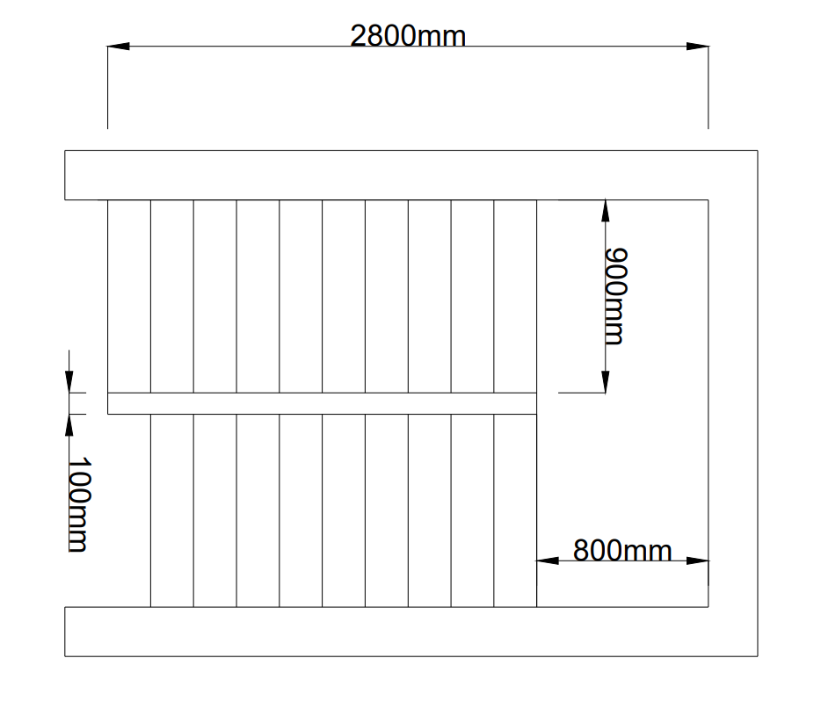
Figure 4.9: staircase.
Each Riser = 150mm
Each Tread = 200mm
No of treads = 10
Length of going = 10 X 200 = 2000mm = 2.0 m
Total length = length of going + width of landing
= 2.0 + 0.8 = 2.8m
Size of staircase room = 2.8 X 1.9
Effective Length:
L_{eff} = $\frac{0.23}{2}+ 2.8+ \frac{0.23}{2}=3.03m$
Depth of the waist slab:
Assuming in between $\frac{l}{25} to \frac{l}{30}$
$$\frac{l}{30}= \frac{3.03}{25}=0.121$$
$$\frac{l}{30}= \frac{3.03}{30}=0.101$$

Take d= 130mm
Assume effective cover = 20mm
d₀ = 130 + 20(cover) + 6(half bar dia) = 156mm
Depth Check:
d₀ Should be grater of the following
i ) 40 x Less = 40 x 3.95 = 158 mm
ii) 100 mm
d₀ = 156 mm
Provide 160mm total thickness
Load calculation :
Self-weight of slab on slope: D × 25 × $\frac{\sqrt{R^{2} + T^{2}}}{T}$ = 0.16 × 25 × $\frac{\sqrt{{0.15}^{2} + {0.2}^{2}}}{0.2}$ = 5 KN/m²
Dead weight of steps: 0.5 × R × 25 = 0.5 × 0.15 × 25 = 1.875 KN/m²
Live Load: 3.0 KN/m²
Floor Finish: 1.0 KN/m²
Total Factored Load (W_{u}): 1.5 × (5.0 + 1.875 + 3.0 + 1.0) = 16.31 KN/m²
Maximum Bending Moment:
M_{u} = $\frac{W_{u }× l^{2}}{8}$ = $\frac{16.31 × {3.03}^{2}}{8}$
M_{u}= 18.72 KN-m
Depth Required:
M_{u}= M_{u limit}
18.72 x 10⁶ = 0.36 x 0.46 (1-0.42 x 0.46) x 1000 x d² x 20
d = 82.4 mm < d _{prov}
hence the section is Safe
Area of Steel:
18.72 x 10⁶ = 0.87 x 500 x A_{st} x 130 x$\left(1-\frac{500X A_{st}}{1000 X 130 X 20}\right)$
A_{st} = 355.31
A_{st min} = $\frac{0.12}{100}X 1000 X 160$ = 192mm²
A_{st} > A_{st min}

A_{st} = 355.31 mm²
Provide 10 mm $∅$ bars @ 200 c/c
Distribution reinforcement:
Provide Minimum reinforce:
Ast = $\frac{0.12}{100}+ 1000 X 150=192{mm}^{2}$
Provide 8 mm bars @ 250mm c/c
4.9 LINTEL DESIGN:
Design a lintel over a door of 1.2m wide. The height of brick work above the opening is 0.725m, masonry weights 19${KN}/{m^{3},}$the brick walls are 230mm thick.Use$M_{20}$ grade concrete and ${Fe}_{500}$grade steel.
Solution:
$f_{CK}$ =20 N/$mm^{2}$
$f_{y}$ =500 N/$mm^{2}$
Depth of beam :
Selecting the depth in range of $\frac{1}{15}to\frac{1}{20}$ based on stiffness.
d = $\frac{1200}{20}$
d = 60mm
Adopt d = 75mm
D =100mm. (assuming 25 mm cover)
Width b =width of the wall = 230 mm.
Assume 150mm bearing on walls.
Effective span:
Centre to centre of supports =1.2 + 0.15 = 1.35 m
Clear span + d =1.2 + 0.075m = 1.275 m
Hence, Effective span =1.275 m
Loads :
Assuming ${60}^{0} d$ispersion,
height of equilateral triangle.
h = l_{eff} $\sin{{60}^{0}}$
h = 1.275$\sin{{60}^{0}}$
h = 1.10 m
1.25h = 1.25 × 1.10
= 1.375 > 0.75m.
Since your masonry height (0.725 m) is less than 1.375 m, the full rectangular load must be considered.
Masonry load $w_{m}$ = 1.275×0.725×0.23×19
= 4.04 KN
Self weight of the lintel${ w}_{d}$= 0.23×0.10×1.275×25
= 0.73 KN/$m$
Total = 4.77 KN
Total factored load (W_{u}) = 7.16 KN
Factored bending moment is ${ M}_{U}$
${ M}_{U}$ = $\frac{{ w}_{ul^{2}}}{8}$
= $\frac{7.16×{1.275}^{2}}{8}$
= 1.14 KN-m
Factored shear force
${ V}_{U}$ = $\frac{{ w}_{u}l}{2}$
= $\frac{7.16×1.275}{2}$
= 4.56 KN.
Depth required:
The minimum depth required to resist bending moment.
${ M}_{U}$ = 0.138$f_{CK}bd^{2}$
1.14×${10}^{6}$ = 0.133×20×230×$d^{2}$
d_{req} = 43
d_{req} = 43mm < 75mm.
hence provided depth is adequate.
Tension reinforcement:
Area of steel is calculated by equating C&T
0.87$f_{y}A_{st}$ = 0.36$f_{CK}b{ x}_{umax}$
$A_{st}$ = $\frac{0.36f_{CK}b x_{umax}}{0.87f_{y} }$
= $\frac{0.36×20×230×0.46×d0}{0.87×500}$
= 131 $mm^{2}$
Provide 2 bars of 10mm Ø,$A_{st}$ provided = 157 $mm^{2}.$
Design of shear reinforcement:
Nominal shear stress ${ τ}_{v}$ =$\frac{V_{U}}{bd }$
= $\frac{4.56×{10}^{3}}{230×75}$
= 0.264 $N/mm^{2}$.
provide minimum shear reinforcement.
Stirrups: Use 6 mm diameter 2-legged stirrups.
Spacing (S_{v}) = Lesser of (0.75 × 75) = 56
Adopt: 6 mmØ stirrups @ 50 mm c/c
CHAPTER 5
DRAWINGS

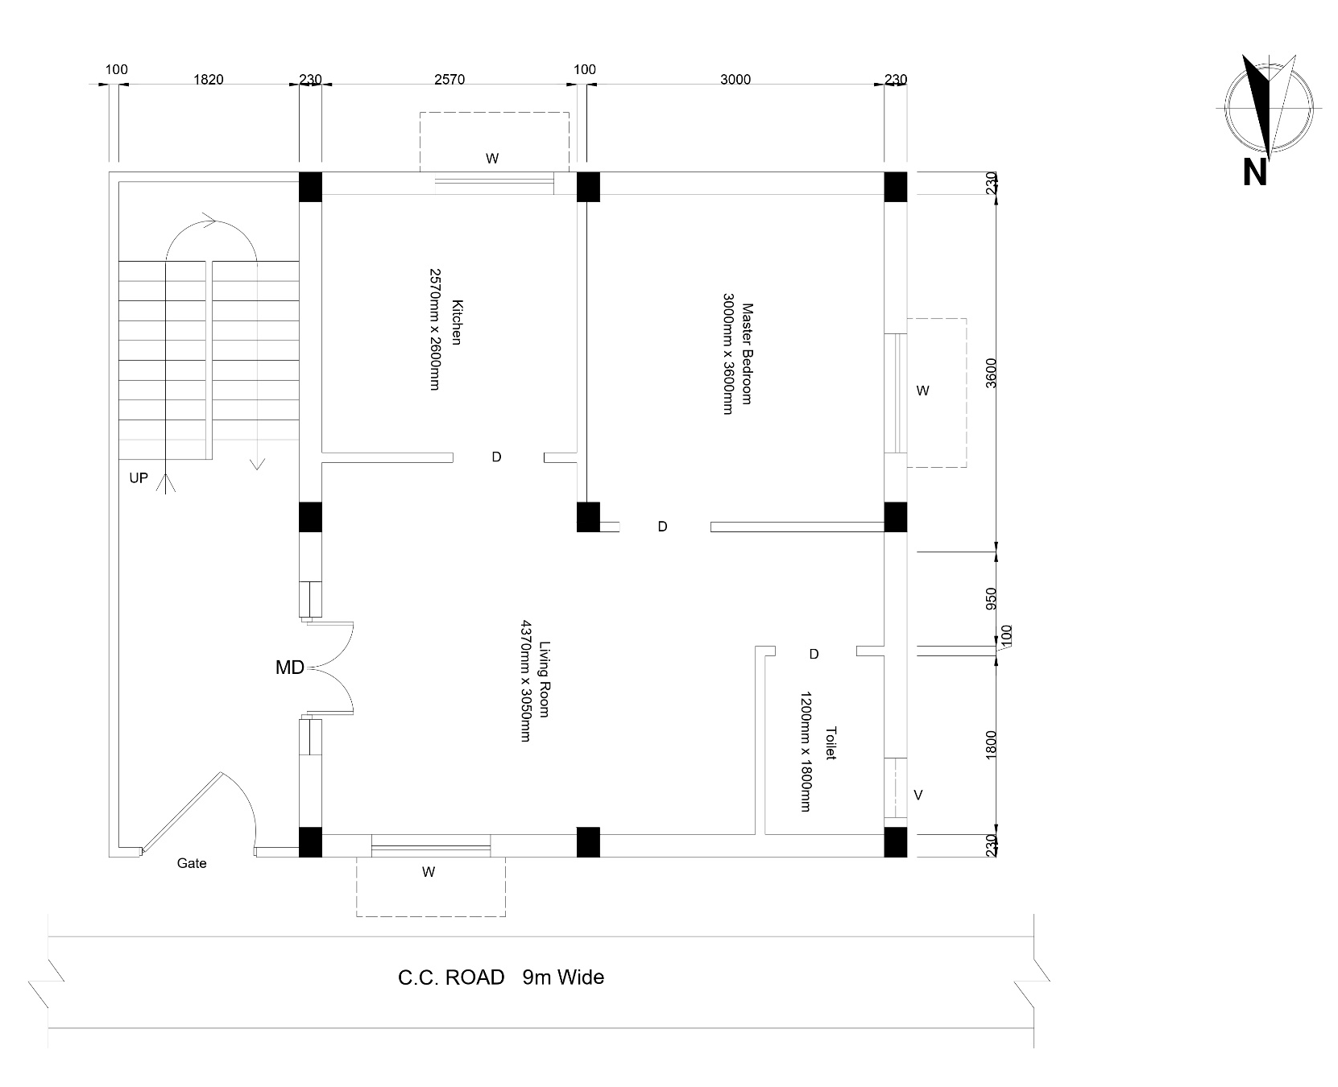
Figure 5.1: ground floor plan

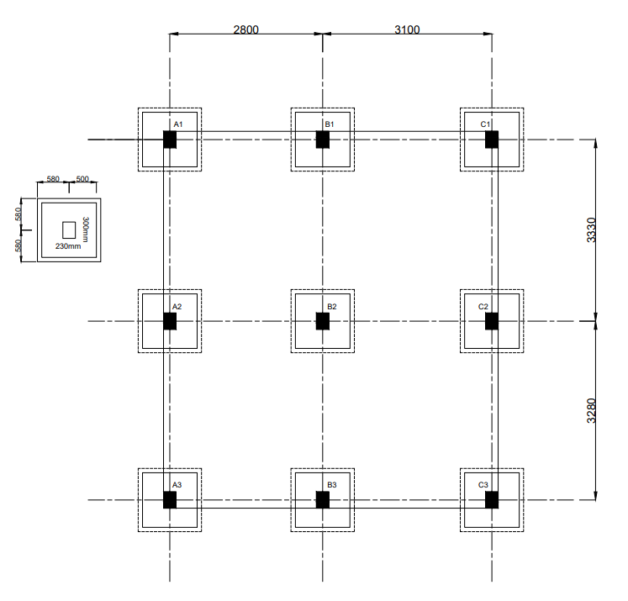

Figure 5.2: Footing layout

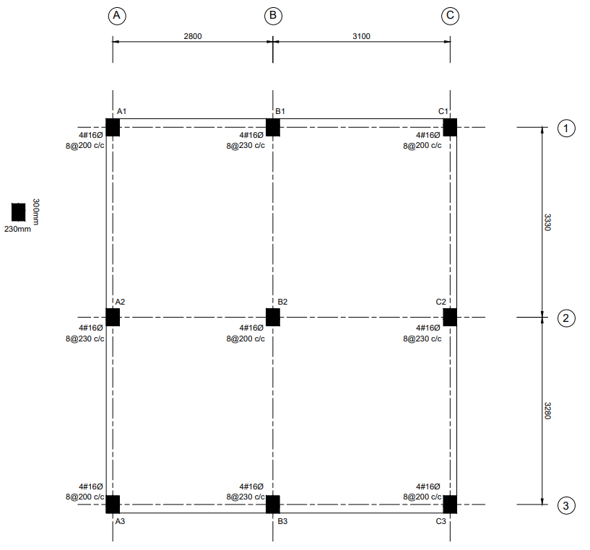

Figure 5.3: Column layout

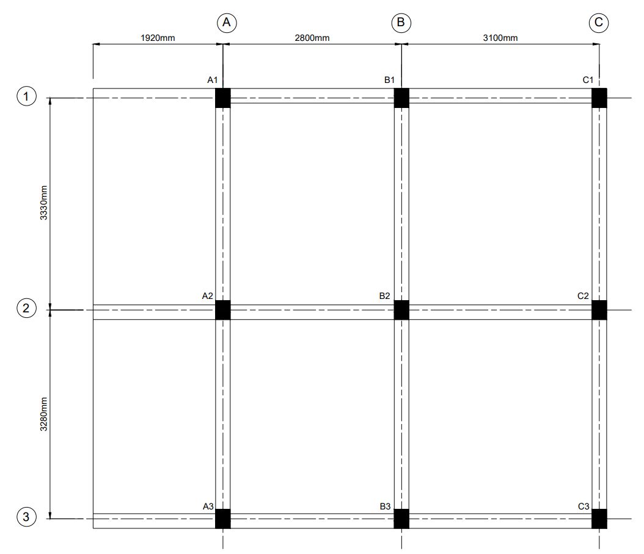

Figure 5.4: Beam layout

REINFORCEMENT DETAILS
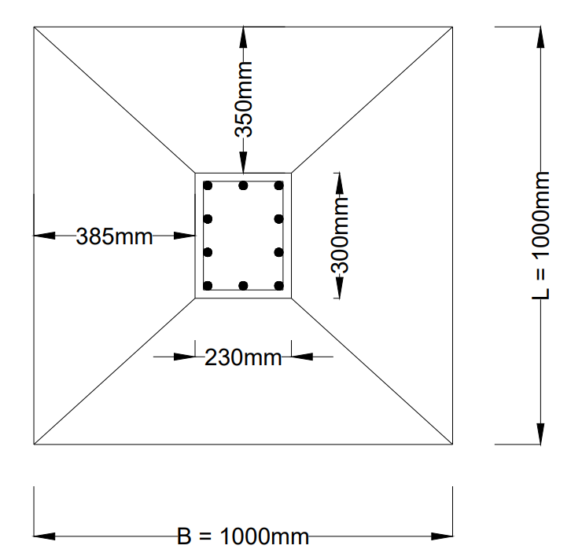

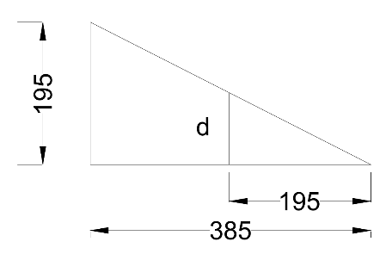

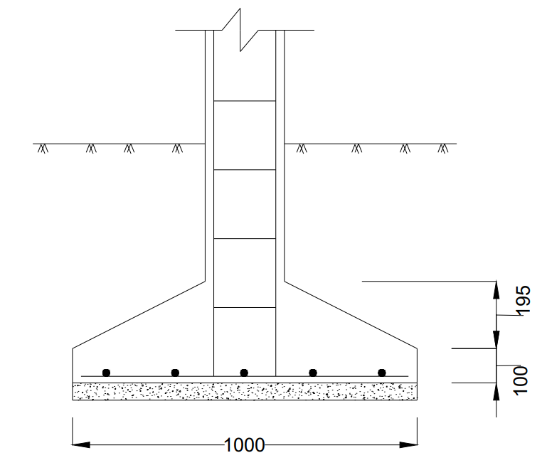

Figure 5.5: Footing reinforcement

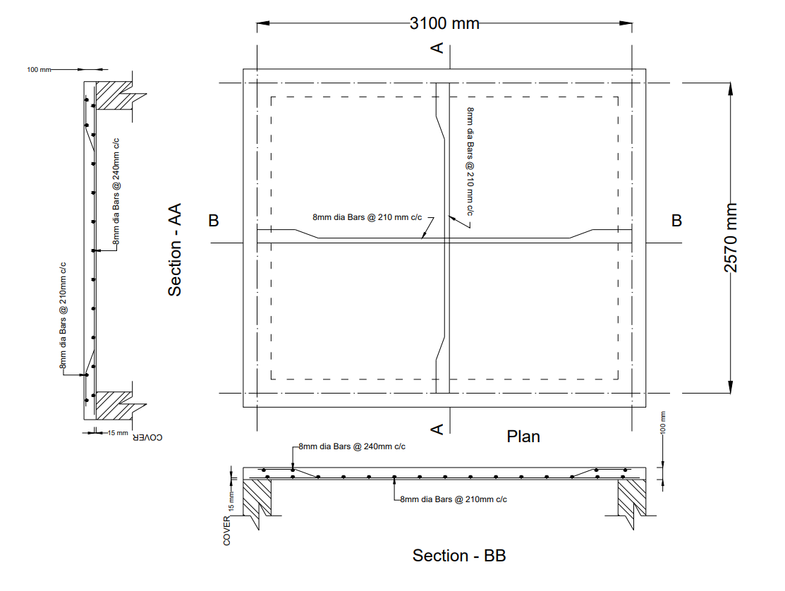
Figure 5.6: Slab reinforcement

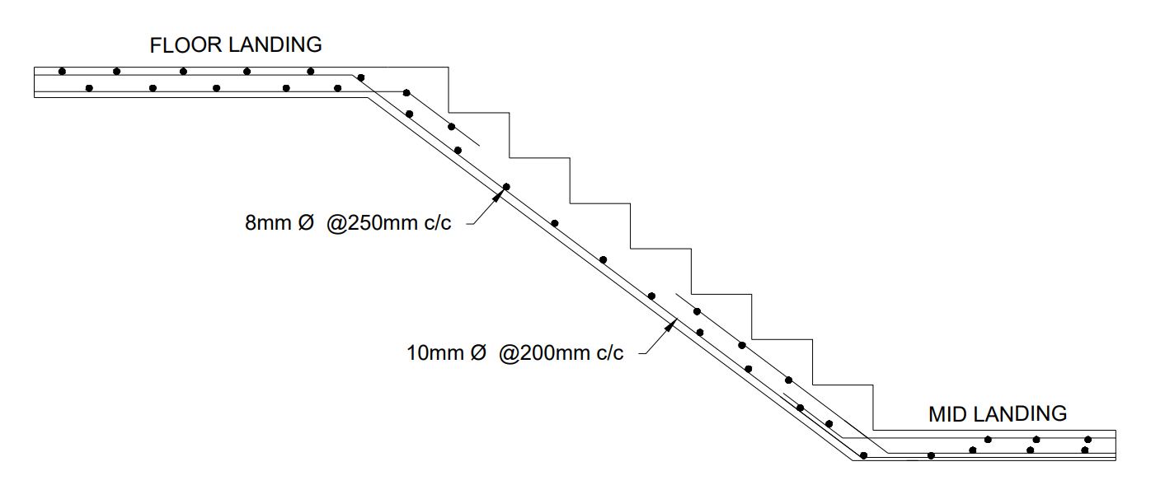
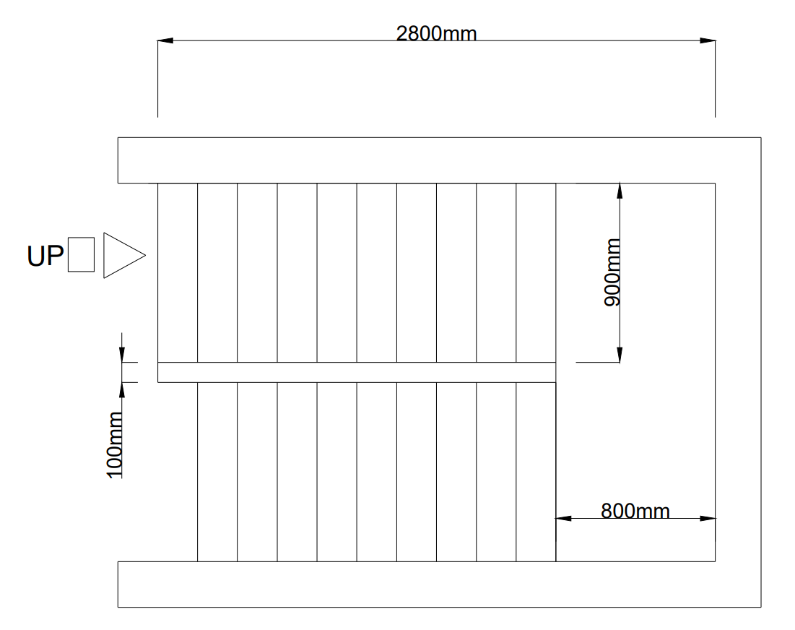
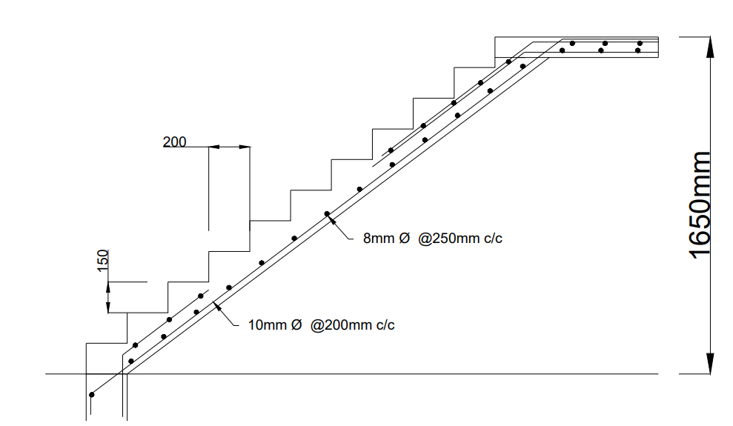
Figure 5.7: Staircase reinforcement

CONCLUSION
The primary objective of this project was to execute the planning, structural analysis, and design single-story (G+0) residential building. This was conducted specifically for the Government of Telangana's 'Indiramma Illu' housing scheme, which aims to provide safe and affordable housing for the poor. By applying core civil engineering principles, this project successfully bridges the gap between stringent economic constraints and the necessity for safe, durable human habitation.
What defines the success of this project is its rigorous engineering methodology: the entire structural framework was calculated and designed completely manually, without reliance on automated structural software. Based on actual site data gathered from a shortlisted beneficiary's plot in Mannapur Village , a highly optimized 590 sq. ft. plinth area was planned. This layout perfectly fulfills the scheme's mandate while maximizing spatial utility for the residents.
The structural analysis was systematically executed using Kani’s Method, allowing for the accurate determination of moments across the continuous beams and columns. Subsequently, the Limit State Method, in strict accordance with IS 456:2000, was utilized to design all vital structural components:
- Roof Slab: Designed safely as a two-way slab with an overall depth of 100 mm. It was mathematically proven to be safe in both bending and deflection.
- Beams & Columns: Meticulously detailed using M20 grade concrete and Fe500 steel. Continuous beams were verified for shear safety with appropriate stirrups , and columns were successfully evaluated and proven safe against both uni-axial and bi-axial bending moments using Bresler's empirical formulation.
- Foundation: A 1.0m x 1.0m rectangular shallow foundation was designed. It was validated against a safe soil bearing capacity of 200 KN/m² and successfully passed all critical checks for both one-way shear and punching (two-way) shear.
Ultimately, this manual design process proves that high-quality, structurally sound housing can be achieved economically. The resulting structural design guarantees minimal material wastage and provides a safe, permanent, and dignified home that fulfills the socio-economic goals of the Indiramma Illu initiative.

REFERENCES
- IS:456-2000, Plain and Reinforced concrete - Code of Practice, Bureau of Indian Standards, New Delhi,
- IS - SP: 16
- IS: 875 : 1987 - (Part-1 & Part-2).
- National building code 2016.
- GO. Ms. No. 168.
- GO.Ms.No.7, G.O.Ms.No.33, G.O.Rt.No.96 & G.O.Rt.No.287
- Design of reinforced concrete by Jain.
- Understanding Concept of Structural Analysis & Design by Janak. P.Parikh.
- Structural Analysis SI edition by Aslam Kassimali.
- Structural Analysis Vol – I & II by Vazarani and Ratwani.
- Advanced Reinforced Concrete Structures by Varghese.
- Reinforced Concrete Structures Vol. 2 by B. C. Punmia.
- Reinforced Concrete Design by S.A. Pilli and D. Menon.

APPENDIX
A = total area
A_{c} = area of concrete
A_{g} = gross area of the section
A_{s}= minimum area of tension reinforcement.
A_{sc} = area of steel in compression.
A_{st} = area of steel in tension
A_{st max} = maximum area of steel required.
A_{st min} = minimum area of steel required.
A_{sv} = total cross-sectional area of stirrup legs effective in shear.
B = width of the section
B_{o} = perimeter of critical section
b = width of the column
b_{e} = Equivalent breadth of the footing
DL = dead load
d = effective depth
d_{o} = D = overall depth
d’ = Effective cover.
E = Young modules of elasticity
e = eccentricity
f_{ck} = Compressive Strength of concrete after 28 days – MPa or N/mm2
F_{e 415} = Grade of steel
f_{s} = Steel stress of service load.
f_{y} = Yield strength of steel – MPa or N/mm2
H = Total height of wall.
K = stiffness of section.
L = length of the section
L_{eff} = Effective Length.

LL = live load
L_{x} = length of the section in X-direction.
L_{y} = length of the section in Y-direction
M = bending moment
M₂₀ = Grade of concrete
M_{u} = moment of resistance of a section without compression reinforcement
M_{u,limit} = Limiting moment of resistance
M_{x} = bending moment along X-axis
M_{y} = bending moment along Y-axis
P = axial load on column
P_{u} = factored axial load on column
q = net upward pressure
q_{u} = ultimate net upward pressure
S = spacing
SBC = The safe bearing capacity of soil
S_{v} = stirrup Spacing along the Length of the member.
T = Tension force.
$τ_{c}$ = Design shear strength of concrete.
$τ_{c max}$= maximum shear stress
$τ_{v}$ = nominal shear stress
V = shear force
V_{u} =Factored shear force
V_{us} =Factored shear force of stirrup
W = total load
x_{u} = depth of neutral axis
x_{u max} = limiting value of depth of neutral axis
Z = Cantilever Projection
∅ = diameter of bar

